POLGEN003 Facilitate community engagement for policing purposes
Release: 1

POLGEN003 Facilitate community engagement for policing purposes

Modification History
Release | Comments
1 | This unit was released in POL Police Training Package release 1.0 and meets the Standards for Training Packages.

Application
This unit describes the skills required to facilitate community engagement, including developing understanding of community specific needs, demonstrating informed practice, and delivering policing services to communities.
This unit applies to those working as a police supervisor with responsibilities to lead the community engagement process.
The skills and knowledge described in this unit must be applied within the legislative, regulatory and policy environment in which they are carried out. Organisational policies and procedures must be consulted and adhered to, particularly those related to codes of ethics and codes of conduct.
Those undertaking this unit would demonstrate strong autonomy, making independent decisions and accessing support from a broad range of services. The individual would be responsible for supervising small teams, providing guidance and assistance, and displaying leadership as part of routine command duties. They would perform routine tasks within familiar and/or unpredictable contexts.
No licensing, legislative or certification requirements apply to unit at the time of publication.

Competency Field
General

Elements and Performance Criteria
ELEMENTS | PERFORMANCE CRITERIA
Elements describe the essential outcomes | Performance criteria describe the performance needed to demonstrate achievement of the element. Where bold italicised text is used, further information is detailed in the range of conditions section.
1. Develop understanding of communities | 1.1 Gather information continuously in order to understand characteristics, complexity and diversity within communities.  1.2 Analyse information to manage communities’ needs, expectations, and perceptions.  1.3 Assess capacity and capability of policing to meet community needs and expectations.
2. Demonstrate informed practice to lead community engagement | 2.1 Use gathered information to develop tailored policing services.  2.2 Communicate diversity issues and expectations to teams.  2.3 Disseminate information to external stakeholders to facilitate the understanding of diversity within communities.  2.4 Provide support and advice to teams to facilitate community engagement.
3. Engage continuously with community | 3.1 Identify jurisdictional objectives to guide approach to community engagement.  3.2 Ensure participation in formal/informal public events to build community confidence and trust.  3.3 Seek out community members to develop networks.  3.4 Liaise with community members to build relationships.  3.5 Conduct risk assessment of community engagement activities to ensure equity of activities across different communities.  3.6 Consult with community members to ensure effective policing service delivery.  3.7 Inform community members of policing matters to reassure communities and build confidence and trust.

Foundation Skills
The foundation skills demands of this unit have been mapped for alignment with the Australian Core Skills Framework (ACSF). The following tables outline the performance levels indicated for successful attainment of the unit.

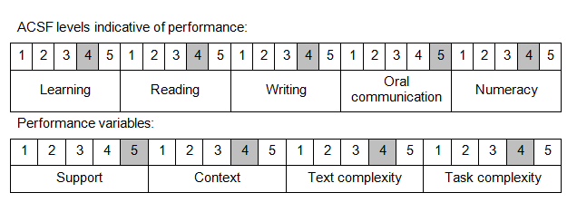

Further information on ACSF and the foundation skills underpinning this unit can be found in the Foundation Skills Guide on the GSA website.

Unit Mapping Information
No equivalent unit.

Links
Companion Volume implementation guides are found in VETNet - https://vetnet.gov.au/Pages/TrainingDocs.aspx?q=98c3984e-2cf1-48a8-8ed1-85e4b92e7351
Companion Volume implementation guides are found in VETNet - https://vetnet.gov.au/Pages/TrainingDocs.aspx?q=98c3984e-2cf1-48a8-8ed1-85e4b92e7351
Companion Volume implementation guides are found in VETNet - https://vetnet.gov.au/Pages/TrainingDocs.aspx?q=98c3984e-2cf1-48a8-8ed1-85e4b92e7351

