POLGEN002 Promote workplace safety within policing
Release: 1

POLGEN002 Promote workplace safety within policing

Modification History
Release | Comments
1 | This unit was released in POL Police Training Package release 1.0 and meets the Standards for Training Packages.

Application
This unit describes the skills required to supervise and protect the safety of individuals within the policing environment. It includes protecting the welfare of individuals within policing, acknowledging that the place of work for police officers differs depending on their role and location of policing functions.
This unit applies to those working as a police supervisor with responsibilities to protect the safety and welfare of individuals and teams.
The skills and knowledge described in this unit must be applied within the legislative, regulatory and policy environment in which they are carried out. Organisational policies and procedures must be consulted and adhered to, particularly those related to work health and safety (WHS), roles and responsibilities, and support services.
Those undertaking this unit would demonstrate strong autonomy, making independent decisions and accessing support from a broad range of services. The individual would be responsible for supervising individuals and teams, providing guidance and assistance, and displaying leadership as part of routine command duties. They would perform complex tasks within familiar and/or unpredictable contexts.
No licensing, legislative or certification requirements apply to unit at the time of publication.

Competency Field
General

Elements and Performance Criteria
ELEMENTS | PERFORMANCE CRITERIA
Elements describe the essential outcomes | Performance criteria describe the performance needed to demonstrate achievement of the element. Where bold italicised text is used, further information is detailed in the range of conditions section.
1. Prevent workplace safety and welfare hazards | 1.1 Identify hazards that may impact upon physical and psychological wellbeing of individuals.  1.2 Assess hazards to develop preventive measures.  1.3 Communicate hazards to prevent harm occurring.  1.4 Implement measures to minimise likelihood and consequences of hazard occurring.  1.5 Monitor individual team behaviours and activities to ensure compliance with jurisdictional policies and procedures.
2. Protect welfare of individuals | 2.1 Assess welfare of individuals affected by workplace hazards.  2.2 Eliminate immediate exposure to workplace hazards to prevent further harm.  2.3 Make referrals to internal and external services to support welfare of individuals affected by hazards.  2.4 Monitor welfare of individuals continuously to maintain safety.
3. Investigate workplace hazards | 3.1 Assess the nature of workplace hazards to determine responses.  3.2 Interview individuals involved to collect information relating to workplace hazards.  3.3 Access external sources of information relating to workplace hazards.  3.4 Liaise with subject matter experts in order to collect information for developing potential solutions to workplace hazards.  3.5 Develop solutions to address workplace hazards.  3.6 Report solutions to identified stakeholders.
4. Implement solutions to workplace hazards | 4.1 Communicate with internal and external stakeholders regarding requirements for solution implementation.  4.2 Arrange service/assistance required to resolve workplace hazards.  4.3 Monitor progress of implementation to protect safety of self, individuals, teams and communities.
5. Evaluate outcomes of solutions | 5.1 Review solutions to ensure workplace hazards were addressed.  5.2 Develop recommendations to prevent reoccurrence of workplace hazards.  5.3 Communicate review findings to stakeholders to inform future activities.

Foundation Skills
The foundation skills demands of this unit have been mapped for alignment with the Australian Core Skills Framework (ACSF). The following tables outline the performance levels indicated for successful attainment of the unit.

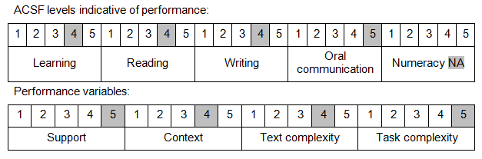

Further information on ACSF and the foundation skills underpinning this unit can be found in the Foundation Skills Guide on the GSA website.

Unit Mapping Information
No equivalent unit.

Links
Companion Volume implementation guides are found in VETNet - https://vetnet.gov.au/Pages/TrainingDocs.aspx?q=98c3984e-2cf1-48a8-8ed1-85e4b92e7351
Companion Volume implementation guides are found in VETNet - https://vetnet.gov.au/Pages/TrainingDocs.aspx?q=98c3984e-2cf1-48a8-8ed1-85e4b92e7351
Companion Volume implementation guides are found in VETNet - https://vetnet.gov.au/Pages/TrainingDocs.aspx?q=98c3984e-2cf1-48a8-8ed1-85e4b92e7351

