POLFOR026 Prepare and present forensic evidence
Release: 1

POLFOR026 Prepare and present forensic evidence

Modification History
Release | Comments
1 | This unit was released in POL Police Training Package release 1.0 and meets the Standards for Training Packages.

Application
This unit describes the skills required to prepare and present evidence, statements and submissions in order to contribute to forensic investigations. This includes the stages of planning, presenting and reviewing evidence.
This unit applies to those working as police staff involved in forensic investigation.
The skills and knowledge described in this unit must be applied within the legislative, regulatory and policy environment in which they are carried out. Organisational policies and procedures must be consulted and adhered to, particularly those related to work health and safety (WHS).
Those undertaking this role would work autonomously while remaining responsible for reporting to senior staff. They would demonstrate adaptability across a broad range of contexts while performing a range of routine tasks.
No licensing, legislative or certification requirements apply to unit at the time of publication.

Competency Field
Forensics

Elements and Performance Criteria
ELEMENTS | PERFORMANCE CRITERIA
Elements describe the essential outcomes | Performance criteria describe the performance needed to demonstrate achievement of the element. Where bold italicised text is used, further information is detailed in the range of conditions section.
1. Prepare forensic documentation | 1.1 Document results to ensure quality and consistency.  1.2 Provide information in reports that conveys outcomes of examinations.  1.3 Identify whether content of report is within own role and responsibility.  1.4 Submit reports to ensure timeliness of results.
2. Prepare for proceedings | 2.1 Confirm arrangements for role and involvement in proceedings.  2.2 Assess case requirements to prepare evidence for presentation.  2.3 Review forensic evidence to ensure accuracy, continuity and integrity before presentation in proceedings.  2.4 Participate in case briefings with relevant personnel.
3. Present evidence | 3.1 Communicate evidence in a clear, concise and articulate manner.  3.2 Describe and explain exhibits to inform proceedings.
4. Review provision of forensic evidence | 4.1 Participate in evaluation of court proceedings to identify issues.  4.2 Communicate issues for quality assurance purposes.  4.3 Evaluate involvement in judicial proceedings to inform future practice.

Foundation Skills
The foundation skills demands of this unit have been mapped for alignment with the Australian Core Skills Framework (ACSF). The following tables outline the performance levels indicated for successful attainment of the unit.

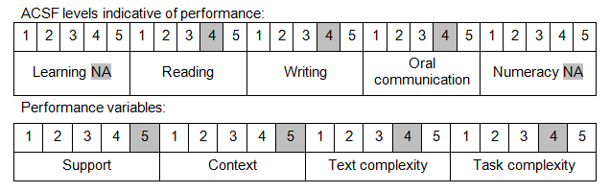

Further information on ACSF and the foundation skills underpinning this unit can be found in the Foundation Skills Guide on the GSA website.

Unit Mapping Information
No equivalent unit.

Links
Companion Volume implementation guides are found in VETNet - https://vetnet.gov.au/Pages/TrainingDocs.aspx?q=98c3984e-2cf1-48a8-8ed1-85e4b92e7351
Companion Volume implementation guides are found in VETNet - https://vetnet.gov.au/Pages/TrainingDocs.aspx?q=98c3984e-2cf1-48a8-8ed1-85e4b92e7351
Companion Volume implementation guides are found in VETNet - https://vetnet.gov.au/Pages/TrainingDocs.aspx?q=98c3984e-2cf1-48a8-8ed1-85e4b92e7351

