POLFOR025 Process forensic evidence
Release: 1

POLFOR025 Process forensic evidence

Modification History
Release | Comments
1 | This unit was released in POL Police Training Package release 1.0 and meets the Standards for Training Packages.  This unit supersedes and is equivalent to PUAPOLFC004B Evaluate and document cases and facilitate analyses.  - Content and formatting updated to comply with new standards  - Unit recoded POL  - Title updated  - Elements 1 and 2 reworded  - PC 1.3 revised  - PC 2.1 removed  - One new PC added to Element 3

Application
This unit describes the skills required to conduct and facilitate the analysis of forensic evidence.
This unit applies to those working as police staff involved in forensic examination.
The skills and knowledge described in this unit must be applied within the legislative, regulatory and policy environment in which they are carried out. Organisational policies and procedures must be consulted and adhered to, particularly those related to work health and safety (WHS).
Those undertaking this role would work autonomously while remaining responsible for reporting to senior staff. They would demonstrate adaptability across a broad range of contexts while performing a range of complex tasks.
No licensing, legislative or certification requirements apply to unit at the time of publication.

Competency Field
Forensics

Elements and Performance Criteria
ELEMENTS | PERFORMANCE CRITERIA
Elements describe the essential outcomes | Performance criteria describe the performance needed to demonstrate achievement of the element. Where bold italicised text is used, further information is detailed in the range of conditions section.
1. Evaluate exhibits | 1.1 Inspect exhibits to ensure integrity has not been compromised.  1.2 Assess case information and exhibit to determine sequence of examination.  1.3 Prioritise examination of exhibits in accordance with investigation requirements.
2. Handle exhibits | 2.1 Complete documentation in accordance with evidentiary requirements.  2.2 Record information using jurisdictional information management systems.  2.3 Store exhibit to ensure continuity, integrity and security.
3. Facilitate examination by forensic practitioners | 3.1 Assess evidence to identify examination requirements.  3.2 Liaise with stakeholders to ensure relevance of examinations.  3.3 Communicate examination requirements to forensic practitioners.  3.4 Coordinate logistics of examination with other forensic practitioners.  3.5 Document movement of exhibits to ensure continuity, security and integrity.

Foundation Skills
The foundation skills demands of this unit have been mapped for alignment with the Australian Core Skills Framework (ACSF). The following tables outline the performance levels indicated for successful attainment of the unit.

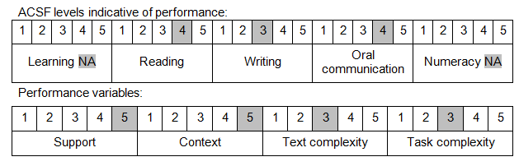

Further information on ACSF and the foundation skills underpinning this unit can be found in the Foundation Skills Guide on the GSA website.

Unit Mapping Information
This unit supersedes and is equivalent to PUAPOLFC004B Evaluate and document cases and facilitate analyses.

Links
Companion Volume implementation guides are found in VETNet - https://vetnet.gov.au/Pages/TrainingDocs.aspx?q=98c3984e-2cf1-48a8-8ed1-85e4b92e7351
Companion Volume implementation guides are found in VETNet - https://vetnet.gov.au/Pages/TrainingDocs.aspx?q=98c3984e-2cf1-48a8-8ed1-85e4b92e7351
Companion Volume implementation guides are found in VETNet - https://vetnet.gov.au/Pages/TrainingDocs.aspx?q=98c3984e-2cf1-48a8-8ed1-85e4b92e7351

