POLFOR024 Detect, record and collect forensic evidence
Release: 1

POLFOR024 Detect, record and collect forensic evidence

Modification History
Release | Comments
1 | This unit was released in POL Police Training Package release 1.0 and meets the Standards for Training Packages.  This unit supersedes and is equivalent to PUAPOLFC003B Detect, record and collect physical evidence.  - Content and formatting updated to comply with new standards  - Unit recoded POL  - Title updated  - Elements 1 and 2 all PC revised  - PC 3.1 and 3.2 revised

Application
This unit describes the skills required to detect, record and collect forensic evidence in order to maximise the potential evidentiary value of exhibits. This may be applied in the field at incident/crime scenes or in a laboratory.
This unit applies to those working as police staff involved in forensic examination.
The skills and knowledge described in this unit must be applied within the legislative, regulatory and policy environment in which they are carried out. Organisational policies and procedures must be consulted and adhered to, particularly those related to work health and safety (WHS).
Those undertaking this role would work autonomously while remaining responsible for reporting to senior staff. They would demonstrate adaptability across a broad range of contexts while performing a range of complex tasks.
No licensing, legislative or certification requirements apply to unit at the time of publication.

Competency Field
Forensics

Elements and Performance Criteria
ELEMENTS | PERFORMANCE CRITERIA
Elements describe the essential outcomes | Performance criteria describe the performance needed to demonstrate achievement of the element. Where bold italicised text is used, further information is detailed in the range of conditions section.
1. Detect physical evidence | 1.1 Apply search methods, observation techniques and technical methods to detect forensic evidence.  1.2 Apply screening techniques to assist in locating forensic evidence.  1.3 Assess forensic evidence to identify potential contamination or loss.  1.4 Preserve forensic evidence to maximise evidentiary value.  1.5 Assess evidence to determine suitability for recording and collection.
2. Record physical evidence | 2.1 Identify recording methods to document forensic evidence and scene.  2.2 Apply enhancement techniques to assist in recording forensic evidence.  2.3 Document details of scene and evidence using note-taking techniques.  2.4 Sketch scene and physical evidence for recording purposes.  2.5 Photograph details of scene and evidence for recording purposes.  2.6 Select markers and scales to accurately represent characteristics and information of the scene.
3. Collect physical evidence | 3.1 Apply swab, lifting and hand picking techniques to gather evidence and reference samples.  3.2 Gather impression evidence using photography, casting and lifting techniques.  3.3 Gather exhibits for further forensic examination.
4. Package forensic evidence | 4.1 Select packaging technique to prevent degradation or contamination.  4.2 Label items to ensure easy identification.  4.3 Seal items to maintain integrity and prevent contamination.  4.4 Assess items to determine if aeration is required.  4.5 Store items to maintain integrity and continuity and to prevent degradation.  4.6 Record details of evidence to enter into case notes and/or exhibit register and to maintain continuity.

Foundation Skills
The foundation skills demands of this unit have been mapped for alignment with the Australian Core Skills Framework (ACSF). The following tables outline the performance levels indicated for successful attainment of the unit.

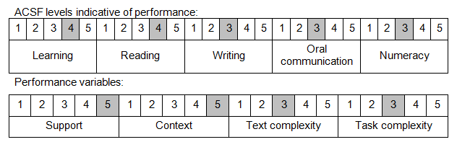

Further information on ACSF and the foundation skills underpinning this unit can be found in the Foundation Skills Guide on the GSA website.

Unit Mapping Information
This unit supersedes and is equivalent to PUAPOLFC003B Detect, record and collect physical evidence.

Links
Companion Volume implementation guides are found in VETNet - https://vetnet.gov.au/Pages/TrainingDocs.aspx?q=98c3984e-2cf1-48a8-8ed1-85e4b92e7351
Companion Volume implementation guides are found in VETNet - https://vetnet.gov.au/Pages/TrainingDocs.aspx?q=98c3984e-2cf1-48a8-8ed1-85e4b92e7351
Companion Volume implementation guides are found in VETNet - https://vetnet.gov.au/Pages/TrainingDocs.aspx?q=98c3984e-2cf1-48a8-8ed1-85e4b92e7351

