POLCOV006 Liaise with clients or stakeholders for intelligence purposes
Release: 1

POLCOV006 Liaise with clients or stakeholders for intelligence purposes

Modification History
Release | Comments
1 | This unit was released in POL Police Training Package release 1.0 and meets the Standards for Training Packages.

Application
This unit describes the skills required for liaising with clients/stakeholders in a policing context to facilitate information and intelligence exchanges within the intelligence process.
This unit applies to those working as intelligence practitioners as part of developing strategic partnerships to support the intelligence process of policing.
The skills and knowledge described in this unit must be applied within the legislative, regulatory and policy environment in which they are carried out. Organisational policies and procedures must be consulted and adhered to, particularly those related to information security, privacy and codes of conduct.
Those undertaking this unit would be expected to work both autonomously and within teams as required. They would be required to apply critical thinking and analytical skills when liaising with stakeholders. They would demonstrate ethical and professional policing qualities, and show adaptability while performing complex tasks across a broad range of contexts.
No licensing, legislative or certification requirements apply to unit at the time of publication.

Competency Field
Covert

Elements and Performance Criteria
ELEMENTS | PERFORMANCE CRITERIA
Elements describe the essential outcomes | Performance criteria describe the performance needed to demonstrate achievement of the element. Where bold italicised text is used, further information is detailed in the range of conditions section.
1. Establish networks and relationships | 1.1 Develop formal and informal networks to support collaboration between the intelligence community and other stakeholders.  1.2 Develop relationships to support identifiable benefits to the intelligence community.  1.3 Support mutual cooperation through participation in cross-jurisdictional/interagency and other stakeholder activities.  1.4 Consult with clients/stakeholders to support jurisdictional and intelligence objectives.
2. Communicate and interact with other stakeholders | 2.1 Provide information to clients/stakeholders to support collaboration.  2.2 Communicate with external agencies in accordance with jurisdictional memoranda of understanding and agreements.  2.3 Collaborate with clients/stakeholders to prevent duplication of effort and improve efficiency and effectiveness for policing and intelligence.

Foundation Skills
The foundation skills demands of this unit have been mapped for alignment with the Australian Core Skills Framework (ACSF). The following tables outline the performance levels indicated for successful attainment of the unit.

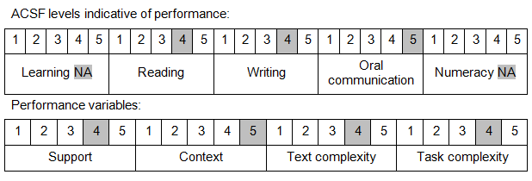

Further information on ACSF and the foundation skills underpinning this unit can be found in the Foundation Skills Guide on the GSA website.

Unit Mapping Information
No equivalent unit.

Links
Companion Volume implementation guides are found in VETNet - https://vetnet.gov.au/Pages/TrainingDocs.aspx?q=98c3984e-2cf1-48a8-8ed1-85e4b92e7351
Companion Volume implementation guides are found in VETNet - https://vetnet.gov.au/Pages/TrainingDocs.aspx?q=98c3984e-2cf1-48a8-8ed1-85e4b92e7351
Companion Volume implementation guides are found in VETNet - https://vetnet.gov.au/Pages/TrainingDocs.aspx?q=98c3984e-2cf1-48a8-8ed1-85e4b92e7351

