POLAUX014 Promote engagement in a policing environment
Release: 1

POLAUX014 Promote engagement in a policing environment

Modification History
Release | Comments
1 | This unit was released in POL Police Training Package release 1.0 and meets the Standards for Training Packages.

Application
This unit describes the skills required to engage with communities in a policing environment, focusing on demonstrating relationship building skills, building consensus among stakeholders and using communication options.
This unit applies to those working as community policing staff, in metropolitan and/or remote areas.
The skills and knowledge described in this unit must be applied within the current legislative, regulatory and policy environment in which they are carried out. Organisational policies and procedures must be consulted and adhered to, particularly those related to customer service, codes of ethics and conduct and anti-discrimination.
Those undertaking this unit would demonstrate autonomy, judgement and limited responsibility within established parameters. They would complete routine and non-routine tasks in an unpredictable context.
No licensing, legislative or certification requirements apply to unit at the time of publication.

Competency Field
Auxiliary

Elements and Performance Criteria
ELEMENTS | PERFORMANCE CRITERIA
Elements describe the essential outcomes | Performance criteria describe the performance needed to demonstrate achievement of the element. Where bold italicised text is used, further information is detailed in the range of conditions section.
1. Engage target audience | 1.1 Assess agency information to identify key messages that meet the needs of a community or community group.  1.2 Protect the security of agency, community and individual information with consideration for level of risk and potential impact.  1.3 Apply engagement techniques to inform a specific target audience.  1.4 Communicate key messages in a clear, concise and accurate manner.  1.5 Evaluate engagement options to determine option best suited to a specific community.
2. Build relationships | 2.1 Identify key community members and other stakeholders to initiate and facilitate engagement.  2.2 Initiate relationships with community members and other stakeholders to facilitate engagement and improve policing service delivery.
3. Build consensus | 3.1 Identify potential conflicts taking into account community and stakeholder needs and perceptions.  3.2 Mediate and negotiate to support collaboration and mutual solving between community and stakeholders.

Foundation Skills
The foundation skills demands of this unit have been mapped for alignment with the Australian Core Skills Framework (ACSF). The following tables outline the performance levels indicated for successful attainment of the unit.

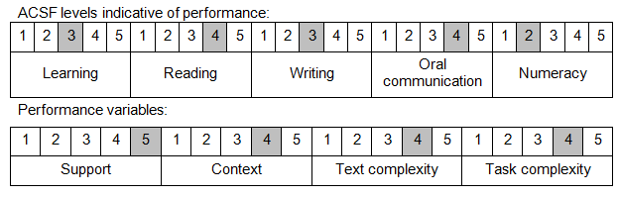

Further information on ACSF and the foundation skills underpinning this unit can be found in the Foundation Skills Guide on the GSA website.

Unit Mapping Information
No equivalent unit.

Links
Companion Volume implementation guides are found in VETNet - https://vetnet.gov.au/Pages/TrainingDocs.aspx?q=98c3984e-2cf1-48a8-8ed1-85e4b92e7351
Companion Volume implementation guides are found in VETNet - https://vetnet.gov.au/Pages/TrainingDocs.aspx?q=98c3984e-2cf1-48a8-8ed1-85e4b92e7351
Companion Volume implementation guides are found in VETNet - https://vetnet.gov.au/Pages/TrainingDocs.aspx?q=98c3984e-2cf1-48a8-8ed1-85e4b92e7351

