POLAUX013 Deliver services to local policing area
Release: 1

POLAUX013 Deliver services to local policing area

Modification History
Release | Comments
1 | This unit was released in POL Police Training Package release 1.0 and meets the Standards for Training Packages.

Application
This unit describes the skills required to apply local policing area knowledge, including gathering information, assessing the local policing context and engaging with communities.
This unit applies to those working as community policing staff, in metropolitan and/or remote areas.
The skills and knowledge described in this unit must be applied within the legislative, regulatory and policy environment in which they are carried out. Organisational policies and procedures must be consulted and adhered to, particularly those relating to work health and safety (WHS) and codes of conduct.
Those undertaking this unit would demonstrate autonomy, judgement and limited responsibility within established parameters. They would complete complex tasks in mostly familiar contexts, that can sometimes be unpredictable.
No licensing, legislative or certification requirements apply to unit at the time of publication.

Competency Field
Auxiliary

Elements and Performance Criteria
ELEMENTS | PERFORMANCE CRITERIA
Elements describe the essential outcomes | Performance criteria describe the performance needed to demonstrate achievement of the element. Where bold italicised text is used, further information is detailed in the range of conditions section.
1. Gather information | 1.1 Collect information in an ethical and professional manner.  1.2 Consider credibility and potential bias of sources to inform use of information.  1.3 Communicate information to stakeholders to facilitate analysis.
2. Consider local policing area | 2.1 Assess persons or groups of interest to identify potential areas of focus for policing responses.  2.2 Identify trends to determine potential impact on local policing area.  2.3 Access sources of information to inform policing responses.  2.4 Select policing response in accordance with jurisdictional strategies, objectives, initiatives and priorities.
3. Provide professional service | 3.1 Identify individual/community profiles and points of diversity to inform policing services.  3.2 Identify police service options to meet individual/community requirements.  3.3 Establish parameters of own role and scope with community for transparency purposes.  3.4 Discuss police service options with members of the community.  3.5 Communicate with individuals/community regarding operational status and matters.  3.6 Seek feedback from community to continuously improve policing service delivery.  3.7 Identify external services available for referral purposes.

Foundation Skills
The foundation skills demands of this unit have been mapped for alignment with the Australian Core Skills Framework (ACSF). The following tables outline the performance levels indicated for successful attainment of the unit.

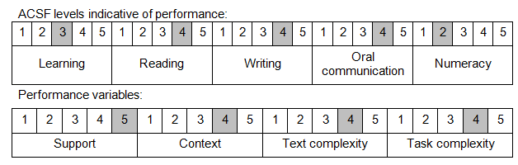

Further information on ACSF and the foundation skills underpinning this unit can be found in the Foundation Skills Guide on the GSA website.

Unit Mapping Information
No equivalent unit.

Links
Companion Volume implementation guides are found in VETNet - https://vetnet.gov.au/Pages/TrainingDocs.aspx?q=98c3984e-2cf1-48a8-8ed1-85e4b92e7351
Companion Volume implementation guides are found in VETNet - https://vetnet.gov.au/Pages/TrainingDocs.aspx?q=98c3984e-2cf1-48a8-8ed1-85e4b92e7351
Companion Volume implementation guides are found in VETNet - https://vetnet.gov.au/Pages/TrainingDocs.aspx?q=98c3984e-2cf1-48a8-8ed1-85e4b92e7351

