POLAUX008 Facilitate public safety awareness activities
Release: 1

POLAUX008 Facilitate public safety awareness activities

Modification History
Release | Comments
1 | This unit was released in POL Police Training Package release 1.0 and meets the Standards for Training Packages.

Application
This unit describes the skills required to facilitate public safety awareness activities, including developing networks and encouraging community participation.
This unit applies to those working as police liaison officers, operating within a policing environment.
The skills and knowledge described in this unit must be applied within the legislative, regulatory and policy environment in which they are carried out. Organisational policies and procedures must be consulted and adhered to, particularly those relating to information security and codes of conduct.
Those undertaking this unit would work independently or under supervision with responsibility for their own functions and outputs. They would undertake defined tasks within established parameters and would develop solutions in predictable contexts.
No licensing, legislative or certification requirements apply to unit at the time of publication.

Competency Field
Auxiliary

Elements and Performance Criteria
ELEMENTS | PERFORMANCE CRITERIA
Elements describe the essential outcomes | Performance criteria describe the performance needed to demonstrate achievement of the element. Where bold italicised text is used, further information is detailed in the range of conditions section.
1. Develop networks within a community | 1.1 Identify stakeholders within the community to determine their issues and concerns.  1.2 Establish rapport with community representatives and groups to facilitate engagement.
2. Support public safety awareness activities | 2.1 Identify need for public safety awareness activities.  2.2 Enlist cooperation and support from stakeholders in planning and initiating public safety awareness activities.  2.3 Participate in the delivery of public safety awareness activities.
3. Report on public safety awareness activities | 3.1 Monitor community perceptions of effectiveness of public safety awareness activity by seeking feedback.  3.2 Review public safety awareness activities for continuous improvement purposes.  3.3 Complete reports detailing activities, results and recommendations in line with organisational guidelines.

Foundation Skills
The foundation skills demands of this unit have been mapped for alignment with the Australian Core Skills Framework (ACSF). The following tables outline the performance levels indicated for successful attainment of the unit.

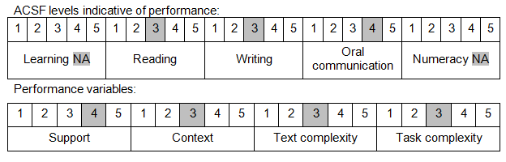

Further information on ACSF and the foundation skills underpinning this unit can be found in the Foundation Skills Guide on the GSA website.

Unit Mapping Information
No equivalent unit.

Links
Companion Volume implementation guides are found in VETNet - https://vetnet.gov.au/Pages/TrainingDocs.aspx?q=98c3984e-2cf1-48a8-8ed1-85e4b92e7351
Companion Volume implementation guides are found in VETNet - https://vetnet.gov.au/Pages/TrainingDocs.aspx?q=98c3984e-2cf1-48a8-8ed1-85e4b92e7351
Companion Volume implementation guides are found in VETNet - https://vetnet.gov.au/Pages/TrainingDocs.aspx?q=98c3984e-2cf1-48a8-8ed1-85e4b92e7351

