POLAUX005 Promote public order through policing services
Release: 1

POLAUX005 Promote public order through policing services

Modification History
Release | Comments
1 | This unit was released in POL Police Training Package release 1.0 and meets the Standards for Training Packages.

Application
This unit describes the skills required to promote public order through policing services, including patrols, initial response and preservation of scenes and evidence.
This unit applies to those working as community police staff, in metropolitan and/or remote areas.
The skills and knowledge described in this unit must be applied within the legislative, regulatory and policy environment in which they are carried out. Organisational policies and procedures must be consulted and adhered to, particularly those relating to information security and codes of conduct.
Those undertaking this unit would demonstrate independent judgement, taking responsibility in known contexts and defined parameters. They would perform routine tasks, whilst providing and transmitting solutions to problems in a range of contexts.
No licensing, legislative or certification requirements apply to unit at the time of publication.

Competency Field
Auxiliary

Elements and Performance Criteria
ELEMENTS | PERFORMANCE CRITERIA
Elements describe the essential outcomes | Performance criteria describe the performance needed to demonstrate achievement of the element. Where bold italicised text is used, further information is detailed in the range of conditions section.
1. Conduct patrols | 1.1 Patrol local policing area for crime prevention and public safety purposes.  1.2 Engage with individuals/community to develop rapport.  1.3 Collect information through patrol activities to identify areas of interest in local policing area.  1.4 Report information relating to local policing area to stakeholders.
2. Perform initial response | 2.1 Observe incident to determine risk and requirement for response.  2.2 Identify resources required for policing response to incident.  2.3 Communicate with stakeholders to facilitate response.  2.4 Respond to incident in a manner which minimises risk to safety of self, colleagues and public.  2.5 Monitor incident to adjust response.  2.6 Communicate outcomes of response.
3. Preserve incident scene and evidence | 3.1 Identify incident scenes requiring investigation to inform stakeholders.  3.2 Secure incident scenes to protect evidence.  3.3 Identify persons of interest at the incident scene for communication to stakeholders.  3.4 Secure evidence to facilitate further investigation.

Foundation Skills
The foundation skills demands of this unit have been mapped for alignment with the Australian Core Skills Framework (ACSF). The following tables outline the performance levels indicated for successful attainment of the unit.

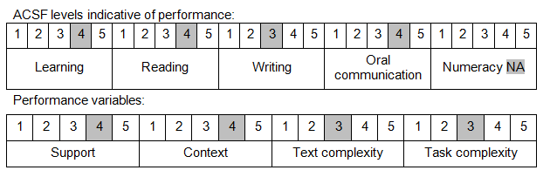

Further information on ACSF and the foundation skills underpinning this unit can be found in the Foundation Skills Guide on the GSA website.

Unit Mapping Information
No equivalent unit.

Links
Companion Volume implementation guides are found in VETNet - https://vetnet.gov.au/Pages/TrainingDocs.aspx?q=98c3984e-2cf1-48a8-8ed1-85e4b92e7351
Companion Volume implementation guides are found in VETNet - https://vetnet.gov.au/Pages/TrainingDocs.aspx?q=98c3984e-2cf1-48a8-8ed1-85e4b92e7351
Companion Volume implementation guides are found in VETNet - https://vetnet.gov.au/Pages/TrainingDocs.aspx?q=98c3984e-2cf1-48a8-8ed1-85e4b92e7351

