POLAUX004 Maintain operational safety in a policing environment
Release: 1

POLAUX004 Maintain operational safety in a policing environment

Modification History
Release | Comments
1 | This unit was released in POL Police Training Package release 1.0 and meets the Standards for Training Packages.

Application
This unit describes the skills required to maintain operational safety in a policing environment, including deploying tactical options and using police equipment.
This unit applies to those working as community police staff, in metropolitan and/or remote areas.
The skills and knowledge described in this unit must be applied within the legislative, regulatory and policy environment in which they are carried out. Organisational policies and procedures must be consulted and adhered to, particularly those relating to work health and safety (WHS) and codes of conduct.
Those undertaking this unit would demonstrate independent judgement, taking responsibility in known contexts and defined parameters. They would perform routine tasks, whilst providing and transmitting solutions to problems in a range of contexts.
No licensing, legislative or certification requirements apply to unit at the time of publication.

Competency Field
Auxiliary

Elements and Performance Criteria
ELEMENTS | PERFORMANCE CRITERIA
Elements describe the essential outcomes | Performance criteria describe the performance needed to demonstrate achievement of the element. Where bold italicised text is used, further information is detailed in the range of conditions section.
1. Assess operational safety risks | 1.1 Monitor environment continually to identify operational safety risks.  1.2 Identify options to select a reasonable and justifiable response.  1.3 Maintain communication with police and other parties throughout response.  1.4 Seek feedback from supervisor regarding response to inform future decisions.
2. Use tactical options | 2.1 Identify tactical options for response based on risk assessment.  2.2 Determine the necessity of tactical options by continually assessing environment.  2.3 Implement tactical options in accordance with situational factors.
3. Handle police equipment | 3.1 Store police equipment to ensure security.  3.2 Use police equipment in a manner which maximises safety of self and others.  3.3 Check police equipment to identify issues or faults.
4. Report operational safety matters | 4.1 Explain use of tactical options based on situational factors.  4.2 Complete documentation requirements relating to operational safety.

Foundation Skills
The foundation skills demands of this unit have been mapped for alignment with the Australian Core Skills Framework (ACSF). The following tables outline the performance levels indicated for successful attainment of the unit.

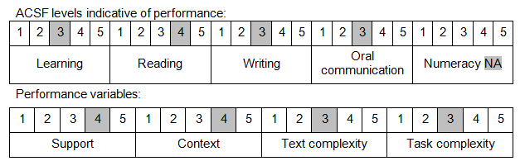

Further information on ACSF and the foundation skills underpinning this unit can be found in the Foundation Skills Guide on the GSA website.

Unit Mapping Information
No equivalent unit.

Links
Companion Volume implementation guides are found in VETNet - https://vetnet.gov.au/Pages/TrainingDocs.aspx?q=98c3984e-2cf1-48a8-8ed1-85e4b92e7351
Companion Volume implementation guides are found in VETNet - https://vetnet.gov.au/Pages/TrainingDocs.aspx?q=98c3984e-2cf1-48a8-8ed1-85e4b92e7351
Companion Volume implementation guides are found in VETNet - https://vetnet.gov.au/Pages/TrainingDocs.aspx?q=98c3984e-2cf1-48a8-8ed1-85e4b92e7351

