POLAUX003 Participate in community engagement activities
Release: 1

POLAUX003 Participate in community engagement activities

Modification History
Release | Comments
1 | This unit was released in POL Police Training Package release 1.0 and meets the Standards for Training Packages.

Application
This unit describes the skills required to participate in community engagement activities, including the application of communication skills and responding to community needs.
This unit applies to those working as police liaison officers operating within a policing environment.
The skills and knowledge described in this unit must be applied within the legislative, regulatory and policy environment in which they are carried out. Organisational policies and procedures must be consulted and adhered to, particularly those relating to codes of conduct.
Those undertaking this unit would work autonomously or under supervision, with responsibility for their own functions and outputs. They would perform tasks within established parameters and would develop solutions in predictable contexts.
No licensing, legislative or certification requirements apply to unit at the time of publication.

Competency Field
Auxiliary

Elements and Performance Criteria
ELEMENTS | PERFORMANCE CRITERIA
Elements describe the essential outcomes | Performance criteria describe the performance needed to demonstrate achievement of the element. Where bold italicised text is used, further information is detailed in the range of conditions section.
1. Communicate verbally and non-verbally | 1.1 Adapt language and non-verbal communication to target audience.  1.2 Apply active listening skills and questioning techniques to clarify issues.  1.3 Use established communication pathways for routine and non-routine communication.
2. Identify response to community needs | 2.1 Engage with community to identify needs.  2.2 Identify range of responses to meet community needs.  2.3 Report range of responses to supervisors to guide community engagement plan.
3. Engage with community | 3.1 Communicate range of possible organisational responses to the community member.  3.2 Relay information to community members clearly, concisely and accurately to enhance understanding.  3.3 Inform community members of options for further action.  3.4 Seek assistance from colleagues to manage community members’ expectations.  3.5 Refer community members to relevant personnel to ensure their needs are managed.

Foundation Skills
The foundation skills demands of this unit have been mapped for alignment with the Australian Core Skills Framework (ACSF). The following tables outline the performance levels indicated for successful attainment of the unit.

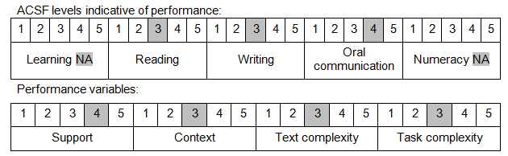

Further information on ACSF and the foundation skills underpinning this unit can be found in the Foundation Skills Guide on the GSA website.

Unit Mapping Information
No equivalent unit.

Links
Companion Volume implementation guides are found in VETNet - https://vetnet.gov.au/Pages/TrainingDocs.aspx?q=98c3984e-2cf1-48a8-8ed1-85e4b92e7351
Companion Volume implementation guides are found in VETNet - https://vetnet.gov.au/Pages/TrainingDocs.aspx?q=98c3984e-2cf1-48a8-8ed1-85e4b92e7351
Companion Volume implementation guides are found in VETNet - https://vetnet.gov.au/Pages/TrainingDocs.aspx?q=98c3984e-2cf1-48a8-8ed1-85e4b92e7351

