POLAUX002 Assist police with members of a culturally specific community
Release: 1

POLAUX002 Assist police with members of a culturally specific community

Modification History
Release | Comments
1 | This unit was released in POL Police Training Package release 1.0 and meets the Standards for Training Packages.  This unit supersedes and is equivalent to PUAPOLIM001A Assist police with members of a culturally specific community.  - Content and formatting updated to comply with the new standards  - Unit recoded POL  - All PC in Elements 1 and 2 revised  - PC 3.3 and 4.4 removed

Application
This unit describes the skills required to apply cultural knowledge to support police engagement with members of culturally specific communities.
This unit applies to those working as police liaison officers operating within a policing environment.
The skills and knowledge described in this unit must be applied within the legislative, regulatory and policy environment in which they are carried out. Organisational policies and procedures must be consulted and adhered to, particularly those relating to codes of conduct.
Those undertaking this unit would work autonomously or under supervision with responsibility for their own functions and outputs. They would defined tasks within established parameters and would develop solutions in mostly predictable contexts.
No licensing, legislative or certification requirements apply to unit at the time of publication.

Competency Field
Auxiliary

Elements and Performance Criteria
ELEMENTS | PERFORMANCE CRITERIA
Elements describe the essential outcomes | Performance criteria describe the performance needed to demonstrate achievement of the element. Where bold italicised text is used, further information is detailed in the range of conditions section.
1. Assist in maintaining police presence | 1.1 Apply cultural knowledge to facilitate police interaction with community.  1.2 Undertake engagement activities in accordance with own role and responsibilities.
2. Assist communication with a culturally specific community | 2.1 Identify cultural considerations.  2.2 Provide advice on cultural considerations which may affect interaction between community and police.  2.3 Adjust communication style to explain information.
3. Consult with a culturally specific community | 3.1 Identify issues affecting police relations with the community to improve engagement.  3.2 Communicate police service strategies to a community to facilitate feedback.  3.3 Report community concerns and suggestions from community to supervisors.
4. Advise police on culturally specific factors | 4.1 Explain cultural considerations and community decision-making practices to enhance police service strategies.  4.2 Identify communication channels to facilitate communication between the community and the police organisation.  4.3 Identify roles of key groups and organisations to establish options for interaction with the community.

Foundation Skills
The foundation skills demands of this unit have been mapped for alignment with the Australian Core Skills Framework (ACSF). The following tables outline the performance levels indicated for successful attainment of the unit.

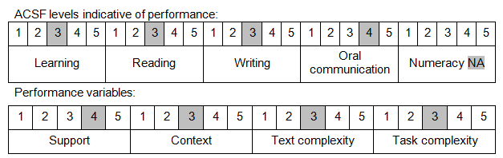

Further information on ACSF and the foundation skills underpinning this unit can be found in the Foundation Skills Guide on the GSA website.

Unit Mapping Information
This unit supersedes and is equivalent to PUAPOLIM001A Assist police with members of a culturally specific community.

Links
Companion Volume implementation guides are found in VETNet - https://vetnet.gov.au/Pages/TrainingDocs.aspx?q=98c3984e-2cf1-48a8-8ed1-85e4b92e7351
Companion Volume implementation guides are found in VETNet - https://vetnet.gov.au/Pages/TrainingDocs.aspx?q=98c3984e-2cf1-48a8-8ed1-85e4b92e7351
Companion Volume implementation guides are found in VETNet - https://vetnet.gov.au/Pages/TrainingDocs.aspx?q=98c3984e-2cf1-48a8-8ed1-85e4b92e7351

