NWPTRT085 Assess and improve wastewater processes to control microbial impacts
Release: 1

NWPTRT085 Assess and improve wastewater processes to control microbial impacts

Modification History
Release | Comments
1 | This unit was released in NWP Water Training Package release 1.0 and meets the Standards for Training Packages.  This unit supersedes and is equivalent to NWP414A Select strategies to control microbial impact on wastewater treatment processes.  - Unit code updated  - Content and formatting updated to comply with the new standards  - All PC transitioned from passive to active voice  - Unit title changed to better reflect unit outcomes  - PC 2.3 revised

Application
This unit describes the skills required to identify wastewater microorganisms and select appropriate measures to optimise the growth of beneficial microorganisms.
This unit applies to those working as wastewater treatment operational specialists.
The skills and knowledge described in this unit must be applied within the legislative, regulatory and policy environment in which they are carried out. Organisational policies and procedures must be consulted and adhered to.
Those undertaking this unit would work autonomously, performing sophisticated tasks in a familiar context.
No licensing, legislative or certification requirements apply to unit at the time of publication.

Competency Field
Treatment

Elements and Performance Criteria
ELEMENTS | PERFORMANCE CRITERIA
Elements describe the essential outcomes | Performance criteria describe the performance needed to demonstrate achievement of the element. Where bold italicised text is used, further information is detailed in the range of conditions section.
1. Investigate wastewater microorganisms | 1.1 Identify a range of typical wastewater microorganisms.  1.2 Identify the general characteristics of different types of microorganisms.  1.3 Identify wastewater characteristics that impact on microorganism growth.  1.4 Identify the problems caused by microorganisms in specific wastewater treatment processes.
2. Select strategies to optimise the growth of beneficial microorganisms | 2.1 Investigate the cause of effluent quality issues.  2.2 Investigate the operational status of the wastewater treatment process.  2.3 Assess the effectiveness of various process control strategies to optimise the growth of beneficial microorganisms.  2.4 Select the most appropriate method.
3. Identify and report on appropriate process controls | 3.1 Identify treatment process conditions for optimising the growth of beneficial microorganisms.  3.2 Report on appropriate treatment processes and associated sampling and testing requirements.

Foundation Skills
The foundation skills demands of this unit have been mapped for alignment with the Australian Core Skills Framework (ACSF). The following tables outline the performance levels indicated for successful attainment of the unit.

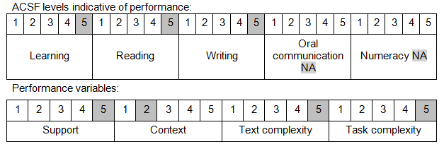

Further information on ACSF and the foundation skills underpinning this unit can be found in the Foundation Skills Guide on the GSA website.

Unit Mapping Information
This unit supersedes and is equivalent to NWP414A Select strategies to control microbial impact on wastewater treatment processes.

Links
Companion Volume implementation guides are found in VETNet - https://vetnet.gov.au/Pages/TrainingDocs.aspx?q=26336bc0-04e5-49d9-8c31-46c49b6a0037
Companion Volume implementation guides are found in VETNet - https://vetnet.gov.au/Pages/TrainingDocs.aspx?q=26336bc0-04e5-49d9-8c31-46c49b6a0037
Companion Volume implementation guides are found in VETNet - https://vetnet.gov.au/Pages/TrainingDocs.aspx?q=26336bc0-04e5-49d9-8c31-46c49b6a0037
Companion Volume implementation guides are found in VETNet - https://vetnet.gov.au/Pages/TrainingDocs.aspx?q=26336bc0-04e5-49d9-8c31-46c49b6a0037

