NWPTRT084 Assess and improve activated sludge and nutrient removal processes
Release: 1

NWPTRT084 Assess and improve activated sludge and nutrient removal processes

Modification History
Release | Comments
1 | This unit was released in NWP Water Training Package release 1.0 and meets the Standards for Training Packages.  This unit supersedes and is equivalent to NWP412A Investigate and plan the optimisation of activated sludge processes.  - Unit code updated  - Content and formatting updated to comply with the new standards  - All PC transitioned from passive to active voice  - Unit title changed to better reflect unit outcomes  - Elements 1 and 2 merged and all PC renumbered  - Element 3 removed  - One new Element added  - PC 4.1 and 4.2 removed  - PC 4.3 revised

Application
This unit describes the skills required to assess, evaluate system performance and investigate and report on the optimisation of activated sludge and nutrient removal treatment processes in maintaining water quality.
This unit applies to those working as technical staff with a specific responsibility for optimising activated sludge and nutrient removal treatment processes.
The skills and knowledge described in this unit must be applied within the legislative, regulatory and policy environment in which they are carried out. Organisational policies and procedures must be consulted and adhered to.
Those undertaking this unit would work under indirect supervision, performing complex tasks in a familiar context.
No licensing, legislative or certification requirements apply to unit at the time of publication.

Competency Field
Treatment

Elements and Performance Criteria
ELEMENTS | PERFORMANCE CRITERIA
Elements describe the essential outcomes | Performance criteria describe the performance needed to demonstrate achievement of the element. Where bold italicised text is used, further information is detailed in the range of conditions section.
1. Assess process | 1.1 Review existing process performance data.  1.2 Review existing operational processes with reference to manufacturer and plant designer specifications.  1.3 Identify the impact of influent quality on treatment process.  1.4 Identify additional sampling and testing required for valid evaluation of current process performance.  1.5 Review existing fault reports and other relevant plant asset information.  1.6 Investigate the operational status of plant components.
2. Improve process | 2.1 Investigate the cause of effluent quality issues.  2.2 Investigate the operational status of the wastewater treatment process.  2.3 Assess the effectiveness of process control strategies.  2.4 Identify treatment process conditions for optimising the growth of beneficial microorganisms.
3. Report on process | 3.1 Compile report on current status.  3.2 Make recommendations on optimisation options.

Foundation Skills
The foundation skills demands of this unit have been mapped for alignment with the Australian Core Skills Framework (ACSF). The following tables outline the performance levels indicated for successful attainment of the unit.

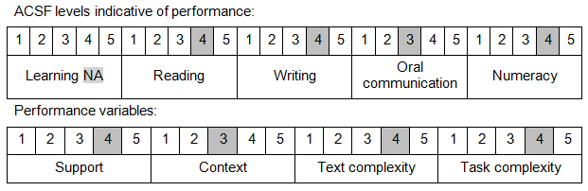

Further information on ACSF and the foundation skills underpinning this unit can be found in the Foundation Skills Guide on the GSA website.

Range of Conditions
Activated sludge processes include: | - sequencing batch reactors (SBR)  - intermittent decant extended aeration (IDEA)  - Bathurst Box  - oxidation ditches
Nutrient removal processes include: | - biological nutrients removal  - fermentation  - pre-fermenters

Unit Mapping Information
This unit supersedes and is equivalent to NWP412A Investigate and plan the optimisation of activated sludge processes.

Links
Companion Volume implementation guides are found in VETNet - https://vetnet.gov.au/Pages/TrainingDocs.aspx?q=26336bc0-04e5-49d9-8c31-46c49b6a0037
Companion Volume implementation guides are found in VETNet - https://vetnet.gov.au/Pages/TrainingDocs.aspx?q=26336bc0-04e5-49d9-8c31-46c49b6a0037
Companion Volume implementation guides are found in VETNet - https://vetnet.gov.au/Pages/TrainingDocs.aspx?q=26336bc0-04e5-49d9-8c31-46c49b6a0037
Companion Volume implementation guides are found in VETNet - https://vetnet.gov.au/Pages/TrainingDocs.aspx?q=26336bc0-04e5-49d9-8c31-46c49b6a0037

