NWPTRT081 Operate and control activated sludge processes
Release: 1

NWPTRT081 Operate and control activated sludge processes

Modification History
Release | Comments
1 | This unit was released in NWP Water Training Package release 1.0 and meets the Standards for Training Packages.  This unit supersedes and is equivalent to NWP351B Monitor, operate and control activated sludge processes.  - Unit code updated  - Content and formatting updated to comply with the new standards  - All PC transitioned from passive to active voice  - Unit title changed to better reflect unit outcomes  - Element 1 revised  - One new PC added to Elements 1 and 2  - Elements 1 and 2 all PC reordered and renumbered  - PC 3.1 removed  - PC 2.1 and 2.3 revised

Application
This unit describes the skills required to operate and control activated sludge processes and to measure and report on system performance and process quality control. The ability to identify faults, determine and apply technical adjustments and conduct chemical dosing procedures is essential to performance.
This unit applies to those working as operational staff with a specific responsibility for wastewater activated sludge in treatment plants.
The skills and knowledge described in this unit must be applied within the legislative, regulatory and policy environment in which they are carried out. Organisational policies and procedures must be consulted and adhered to.
Those undertaking this unit would work under supervision, performing routine tasks within a familiar context.
No licensing, legislative or certification requirements apply to unit at the time of publication.

Competency Field
Treatment

Elements and Performance Criteria
ELEMENTS | PERFORMANCE CRITERIA
Elements describe the essential outcomes | Performance criteria describe the performance needed to demonstrate achievement of the element. Where bold italicised text is used, further information is detailed in the range of conditions section.
1. Plan and prepare for work | 1.1 Determine work requirements from job specification and plans.  1.2 Select and check equipment required to meet safety requirements of task and site.  1.3 Select, fit and use personal protective equipment.
2. Operate and control process | 2.1 Carry out routine inspection on assets.  2.2 Collect process samples.  2.3 Carry out routine tests.  2.4 Prepare samples for laboratory testing.  2.5 Identify and report process faults and operational condition of assets.  2.6 Carry out basic process adjustments to enhance process performance.  2.7 Monitor processes to maintain parameters of operation.
3. Complete documentation | 3.1 Collect, record and complete process data.  3.2 Identify data that falls outside normal parameters and report for further action.

Foundation Skills
The foundation skills demands of this unit have been mapped for alignment with the Australian Core Skills Framework (ACSF). The following tables outline the performance levels indicated for successful attainment of the unit.

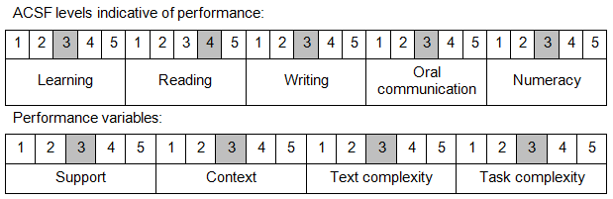

Further information on ACSF and the foundation skills underpinning this unit can be found in the Foundation Skills Guide on the GSA website.

Range of Conditions
Current processes include: | - intermittent decanted extended aeration (IDEA)  - sequencing batch reactors (SBR)  - Bathurst Box  - oxidation ditches

Unit Mapping Information
This unit supersedes and is equivalent to NWP351B Monitor, operate and control activated sludge processes.

Links
Companion Volume implementation guides are found in VETNet - https://vetnet.education.gov.au/Pages/TrainingDocs.aspx?q=26336bc0-04e5-49d9-8c31-46c49b6a0037
Companion Volume implementation guides are found in VETNet - https://vetnet.education.gov.au/Pages/TrainingDocs.aspx?q=26336bc0-04e5-49d9-8c31-46c49b6a0037
Companion Volume implementation guides are found in VETNet - https://vetnet.education.gov.au/Pages/TrainingDocs.aspx?q=26336bc0-04e5-49d9-8c31-46c49b6a0037
Companion Volume implementation guides are found in VETNet - https://vetnet.education.gov.au/Pages/TrainingDocs.aspx?q=26336bc0-04e5-49d9-8c31-46c49b6a0037

