NWPTRT056 Operate and control ozone processes
Release: 1

NWPTRT056 Operate and control ozone processes

Modification History
Release | Comments
1 | This unit was released in NWP Water Training Package release 1.0 and meets the Standards for Training Packages.  This unit supersedes and is equivalent to NWP274A Monitor, operate and report ozone treatment systems.  - Unit code updated  - Content and formatting updated to comply with the new standards  - All PC transitioned from passive to active voice  - Unit title changed to better reflect unit outcomes  - PC 2.4 renumbered  - PC 4.2 revised

Application
This unit describes the skills required to monitor and operate ozone treatment systems and to report on process quality control.
This unit applies to those working as operational staff with specific responsibility for ensuring that ozone treatment systems comply with organisational requirements.
The skills and knowledge described in this unit must be applied within the legislative, regulatory and policy environment in which they are carried out. Organisational policies and procedures must be consulted and adhered to, particularly those relating to hazardous substance handling and WHS.
Those undertaking this unit would work under supervision while performing routine tasks in a range of familiar contexts.
No licensing, legislative or certification requirements apply to unit at the time of publication.

Competency Field
Treatment

Elements and Performance Criteria
ELEMENTS | PERFORMANCE CRITERIA
Elements describe the essential outcomes | Performance criteria describe the performance needed to demonstrate achievement of the element. Where bold italicised text is used, further information is detailed in the range of conditions section.
1. Plan and prepare for work | 1.1 Determine work requirements as outlined in the standard operating procedure.  1.2 Select and check equipment and tools required to meet safety requirements of task and site.  1.3 Select, fit and use personal protective equipment.
2. Monitor system performance | 2.1 Monitor ozone treatment processes.  2.2 Collect process samples and conduct standard tests.  2.3 Maintain and monitor relevant WHS requirements.
3. Prepare and apply ozone dosing | 3.1 Generate and dose ozone.  3.2 Maintain information relating to ozone generation and dosing.
4. Complete and review reports | 4.1 Collect and report process data.  4.2 Produce information relating to system maintenance and operation.  4.3 Report observations outside defined parameters for further action.

Foundation Skills
The foundation skills demands of this unit have been mapped for alignment with the Australian Core Skills Framework (ACSF). The following tables outline the performance levels indicated for successful attainment of the unit.

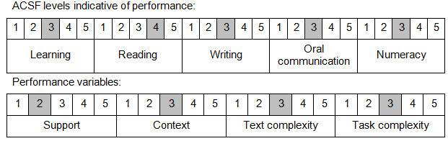

Further information on ACSF and the foundation skills underpinning this unit can be found in the Foundation Skills Guide on the GSA website.

Unit Mapping Information
This unit supersedes and is equivalent to NWP274A Monitor, operate and report ozone treatment systems.

Links
Companion Volume implementation guides are found in VETNet - https://vetnet.education.gov.au/Pages/TrainingDocs.aspx?q=26336bc0-04e5-49d9-8c31-46c49b6a0037
Companion Volume implementation guides are found in VETNet - https://vetnet.education.gov.au/Pages/TrainingDocs.aspx?q=26336bc0-04e5-49d9-8c31-46c49b6a0037
Companion Volume implementation guides are found in VETNet - https://vetnet.education.gov.au/Pages/TrainingDocs.aspx?q=26336bc0-04e5-49d9-8c31-46c49b6a0037
Companion Volume implementation guides are found in VETNet - https://vetnet.education.gov.au/Pages/TrainingDocs.aspx?q=26336bc0-04e5-49d9-8c31-46c49b6a0037

