NWPTRT055 Operate chlorine dioxide processes
Release: 1

NWPTRT055 Operate chlorine dioxide processes

Modification History
Release | Comments
1 | This unit was released in NWP Water Training Package release 1.0 and meets the Standards for Training Packages.  This unit supersedes and is equivalent to NWP275A Monitor, operate and report chlorine dioxide systems.  - Unit code updated  - Content and formatting updated to comply with the new standards  - All PC transitioned from passive to active voice  - Unit title changed to better reflect unit outcomes

Application
This unit describes the skills required to monitor and operate chlorine dioxide systems and to report on process quality control.
This unit applies to those working as operational staff with specific responsibility for ensuring chlorine dioxide system processes comply with organisational requirements.
The skills and knowledge described in this unit must be applied within the legislative, regulatory and policy environment in which they are carried out. Organisational policies and procedures must be consulted and adhered to, particularly those relating to WHS and hazardous substance handling.
Those undertaking this unit would work under supervision while performing routine tasks in a range of familiar contexts.
No licensing, legislative or certification requirements apply to unit at the time of publication.

Competency Field
Treatment

Elements and Performance Criteria
ELEMENTS | PERFORMANCE CRITERIA
Elements describe the essential outcomes | Performance criteria describe the performance needed to demonstrate achievement of the element. Where bold italicised text is used, further information is detailed in the range of conditions section.
1. Plan and prepare for work | 1.1 Determine work requirements from standard operating procedures.  1.2 Select and check equipment and tools required to meet safety requirements of task and site.  1.3 Select, fit and use personal protective equipment.
2. Monitor system performance | 2.1 Monitor chlorine dioxide processes.  2.2 Collect process samples and conduct standard tests.  2.3 Maintain and monitor relevant WHS requirements.
3. Prepare and apply chemical dosing | 3.1 Handle, use and store chemicals.  3.2 Prepare chemical dosing.  3.3 Maintain information relating to chemical supply and usage according to statutory requirements.
4. Complete documentation | 4.1 Collect and report process data.  4.2 Review information and contribute to enterprise processes for continuous improvement and incident management.

Foundation Skills
The foundation skills demands of this unit have been mapped for alignment with the Australian Core Skills Framework (ACSF). The following tables outline the performance levels indicated for successful attainment of the unit.

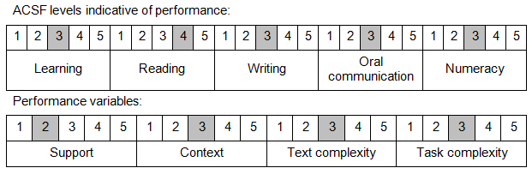

Further information on ACSF and the foundation skills underpinning this unit can be found in the Foundation Skills Guide on the GSA website.

Unit Mapping Information
This unit supersedes and is equivalent to NWP275A Monitor, operate and report chlorine dioxide systems.

Links
Companion Volume implementation guides are found in VETNet - https://vetnet.education.gov.au/Pages/TrainingDocs.aspx?q=26336bc0-04e5-49d9-8c31-46c49b6a0037
Companion Volume implementation guides are found in VETNet - https://vetnet.education.gov.au/Pages/TrainingDocs.aspx?q=26336bc0-04e5-49d9-8c31-46c49b6a0037
Companion Volume implementation guides are found in VETNet - https://vetnet.education.gov.au/Pages/TrainingDocs.aspx?q=26336bc0-04e5-49d9-8c31-46c49b6a0037
Companion Volume implementation guides are found in VETNet - https://vetnet.education.gov.au/Pages/TrainingDocs.aspx?q=26336bc0-04e5-49d9-8c31-46c49b6a0037

