NWPTRT054 Operate and control chloramination processes
Release: 1

NWPTRT054 Operate and control chloramination processes

Modification History
Release | Comments
1 | This unit was released in NWP Water Training Package release 1.0 and meets the Standards for Training Packages.  This unit supersedes and is equivalent to NWP366A Monitor, operate and control chloramination disinfection processes.  - Unit code updated  - Content and formatting updated to comply with the new standards  - All PC transitioned from passive to active voice  - Unit title changed to better reflect unit outcomes  - Elements reordered  - One new PC added to Element 1

Application
This unit describes the skills required to monitor, operate and control chloramination processes; and to measure and report on system performance and process quality control. The ability to identify faults, determine and apply technical adjustments is essential to performance.
This unit applies to those working as operational staff with a specific responsibility for chloramination processes.
The skills and knowledge described in this unit must be applied within the legislative, regulatory and policy environment in which they are carried out. Organisational policies and procedures must be consulted and adhered to, particularly those relating to storage and handling of hazardous substances and dangerous goods.
Those undertaking this unit would work under supervision, while performing routine tasks, within a range of familiar contexts.
No licensing, legislative or certification requirements apply to unit at the time of publication.

Competency Field
Treatment

Elements and Performance Criteria
ELEMENTS | PERFORMANCE CRITERIA
Elements describe the essential outcomes | Performance criteria describe the performance needed to demonstrate achievement of the element. Where bold italicised text is used, further information is detailed in the range of conditions section.
1. Monitor chloramination process performance | 1.1 Conduct and analyse process tests and compare performance to plant operational requirements.  1.2 Collect samples and test chlorine residuals.  1.3 Identify and report process faults and the operational condition of plant.
2. Prepare and apply chloramination chemical dosing | 2.1 Use, handle and store chemicals.  2.2 Prepare chemical dosing according to system specifications and organisational requirements.  2.3 Maintain information related to chlorine and ammonia supply and usage.
3. Operate and control chloramination processes | 3.1 Carry out routine plant inspections.  3.2 Make adjustments to dosing to optimise system performance.
4. Complete documentation | 4.1 Collect and record process data.  4.2 Report observations outside defined parameters for further action.

Foundation Skills
The foundation skills demands of this unit have been mapped for alignment with the Australian Core Skills Framework (ACSF). The following tables outline the performance levels indicated for successful attainment of the unit.

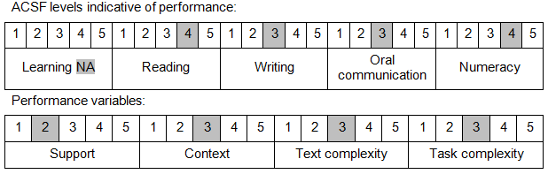

Further information on ACSF and the foundation skills underpinning this unit can be found in the Foundation Skills Guide on the GSA website.

Unit Mapping Information
This unit supersedes and is equivalent to NWP366A Monitor, operate and control chloramination disinfection processes.

Links
Companion Volume implementation guides are found in VETNet - https://vetnet.education.gov.au/Pages/TrainingDocs.aspx?q=26336bc0-04e5-49d9-8c31-46c49b6a0037
Companion Volume implementation guides are found in VETNet - https://vetnet.education.gov.au/Pages/TrainingDocs.aspx?q=26336bc0-04e5-49d9-8c31-46c49b6a0037
Companion Volume implementation guides are found in VETNet - https://vetnet.education.gov.au/Pages/TrainingDocs.aspx?q=26336bc0-04e5-49d9-8c31-46c49b6a0037
Companion Volume implementation guides are found in VETNet - https://vetnet.education.gov.au/Pages/TrainingDocs.aspx?q=26336bc0-04e5-49d9-8c31-46c49b6a0037

