NWPTRT044 Operate and control desalination processes
Release: 1

NWPTRT044 Operate and control desalination processes

Modification History
Release | Comments
1 | This unit was released in NWP Water Training Package release 1.0 and meets the Standards for Training Packages.  - New unit, created drawing upon information from deleted unit NWP357B

Application
This unit describes the skills required to monitor, operate and control a desalination plant, and to measure and report on system performance and process quality control. The ability to identify faults and determine and apply technical adjustments is essential to performance.
This unit applies to those working as operational staff with a specific responsibility for desalination processes in treatment plants.
The skills and knowledge described in this unit must be applied within the legislative, regulatory and policy environment in which they are carried out. Organisational policies and procedures must be consulted and adhered to.
Those undertaking this unit would work under supervision, while performing routine tasks, within a familiar context.
No licensing, legislative or certification requirements apply to unit at the time of publication.

Competency Field
Treatment

Elements and Performance Criteria
ELEMENTS | PERFORMANCE CRITERIA
Elements describe the essential outcomes | Performance criteria describe the performance needed to demonstrate achievement of the element. Where bold italicised text is used, further information is detailed in the range of conditions section.
1. Monitor desalination processes | 1.1 Monitor test results and processes to maintain the parameters of operation.  1.2 Identify and report process faults and the operational condition of plant.
2. Operate and control desalination processes | 2.1 Carry out routine plant inspections.  2.2 Conduct and analyse process tests and compare performance to plant operational requirements.  2.3 Make integrated process adjustments to optimise system performance.  2.4 Select, fit and use required safety equipment, including personal protective equipment.
3. Complete documentation | 3.1 Collect, interpret and record process data.  3.2 Report observations outside defined parameters for further action.

Foundation Skills
The foundation skills demands of this unit have been mapped for alignment with the Australian Core Skills Framework (ACSF). The following tables outline the performance levels indicated for successful attainment of the unit.

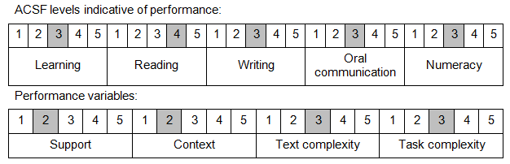

Further information on ACSF and the foundation skills underpinning this unit can be found in the Foundation Skills Guide on the GSA website.

Range of Conditions
Desalination processes include: | - reverse osmosis  - nanofiltration (NF)  - electrodialysis reversal (EDR)  - thermal desalination

Unit Mapping Information
No equivalent unit.

Links
Companion Volume implementation guides are found in VETNet - https://vetnet.education.gov.au/Pages/TrainingDocs.aspx?q=26336bc0-04e5-49d9-8c31-46c49b6a0037
Companion Volume implementation guides are found in VETNet - https://vetnet.education.gov.au/Pages/TrainingDocs.aspx?q=26336bc0-04e5-49d9-8c31-46c49b6a0037
Companion Volume implementation guides are found in VETNet - https://vetnet.education.gov.au/Pages/TrainingDocs.aspx?q=26336bc0-04e5-49d9-8c31-46c49b6a0037
Companion Volume implementation guides are found in VETNet - https://vetnet.education.gov.au/Pages/TrainingDocs.aspx?q=26336bc0-04e5-49d9-8c31-46c49b6a0037

