NWPTRT043 Operate and control membrane filters
Release: 1

NWPTRT043 Operate and control membrane filters

Modification History
Release | Comments
1 | This unit was released in NWP Water Training Package release 1.0 and meets the Standards for Training Packages.  This unit supersedes and is equivalent to NWP355B Monitor, operate and control membrane filtration processes.  - Unit code updated  - Content and formatting updated to comply with the new standards  - All PC transitioned from passive to active voice  - Unit title changed to better reflect unit outcomes

Application
This unit of competency describes the skills required to monitor, operate and control membrane filtration plant, including micro and ultrafiltration, and to measure and report on system performance and process quality control. The ability to identify faults, determine and apply technical adjustments and conduct chemical dosing procedures is essential to performance.
This unit applies to operational staff members with a specific responsibility for membrane filtration processes in treatment plants.
The skills and knowledge described in this unit must be applied within the legislative, regulatory and policy environment in which they are carried out. Organisational policies and procedures must be consulted and adhered to, particularly those relating to WHS.
Those undertaking this unit would work under supervision, while performing routine tasks, within a familiar context.
No licensing, legislative or certification requirements apply to unit at the time of publication.

Competency Field
Treatment

Elements and Performance Criteria
ELEMENTS | PERFORMANCE CRITERIA
Elements describe the essential outcomes | Performance criteria describe the performance needed to demonstrate achievement of the element. Where bold italicised text is used, further information is detailed in the range of conditions section.
1. Monitor membrane filtration plant performance | 1.1 Monitor test results and processes to maintain the parameters of operation.  1.2 Identify and report process faults and the operational condition of plant.  1.3 Select, fit and use required safety equipment, including personal protective equipment.
2. Control chemical use | 2.1 Use, handle and store chemicals.  2.2 Determine chemical dosing.  2.3 Maintain chemical supply and usage records.
3. Operate and control membrane filtration process | 3.1 Carry out routine plant inspections.  3.2 Conduct and analyse process tests and determine performance against plant operational requirements.  3.3 Make integrated process adjustments to improve system performance.
4. Complete documentation | 4.1 Collect and record process data.  4.2 Report observations outside defined parameters for further action.

Foundation Skills
The foundation skills demands of this unit have been mapped for alignment with the Australian Core Skills Framework (ACSF). The following tables outline the performance levels indicated for successful attainment of the unit.

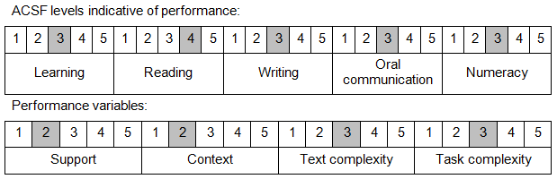

Further information on ACSF and the foundation skills underpinning this unit can be found in the Foundation Skills Guide on the GSA website.

Unit Mapping Information
This unit supersedes and is equivalent to NWP355B Monitor, operate and control membrane filtration processes.

Links
Companion Volume implementation guides are found in VETNet - https://vetnet.education.gov.au/Pages/TrainingDocs.aspx?q=26336bc0-04e5-49d9-8c31-46c49b6a0037
Companion Volume implementation guides are found in VETNet - https://vetnet.education.gov.au/Pages/TrainingDocs.aspx?q=26336bc0-04e5-49d9-8c31-46c49b6a0037
Companion Volume implementation guides are found in VETNet - https://vetnet.education.gov.au/Pages/TrainingDocs.aspx?q=26336bc0-04e5-49d9-8c31-46c49b6a0037
Companion Volume implementation guides are found in VETNet - https://vetnet.education.gov.au/Pages/TrainingDocs.aspx?q=26336bc0-04e5-49d9-8c31-46c49b6a0037

