NWPTRT034 Operate and control activated carbon processes
Release: 1

NWPTRT034 Operate and control activated carbon processes

Modification History
Release | Comments
1 | This unit was released in NWP Water Training Package release 1.0 and meets the Standards for Training Packages.  - New unit, created drawing upon information from deleted unit NWP367A

Application
This unit describes the skills required to operate and control activated carbon processes. The ability to identify faults and determine and apply technical adjustments is essential to performance.
This unit applies to those working as operational staff in treatment.
The skills and knowledge described in this unit must be applied within the legislative, regulatory and policy environment in which they are carried out. Organisational policies and procedures must be consulted and adhered to.
Those undertaking this unit would work under supervision, while performing routine tasks, within a familiar context.
No licensing, legislative or certification requirements apply to unit at the time of publication.

Competency Field
Treatment

Elements and Performance Criteria
ELEMENTS | PERFORMANCE CRITERIA
Elements describe the essential outcomes | Performance criteria describe the performance needed to demonstrate achievement of the element. Where bold italicised text is used, further information is detailed in the range of conditions section.
1. Plan and prepare for work | 1.1 Determine work requirements.  1.2 Select and check equipment to meet safety requirements of task and site.  1.3 Select, fit and use personal protective equipment.
2. Operate and control process | 2.1 Carry out routine inspection on assets.  2.2 Collect process samples.  2.3 Carry out routine tests.  2.4 Prepare samples for laboratory testing.  2.5 Identify and report process faults and operational condition of assets.  2.6 Carry out basic process adjustments to enhance process performance.  2.7 Monitor processes to maintain parameters of operation.
3. Complete documentation | 3.1 Collect and record and complete process data.  3.2 Identify data that falls outside normal parameters and report for further action.

Foundation Skills
The foundation skills demands of this unit have been mapped for alignment with the Australian Core Skills Framework (ACSF). The following tables outline the performance levels indicated for successful attainment of the unit.

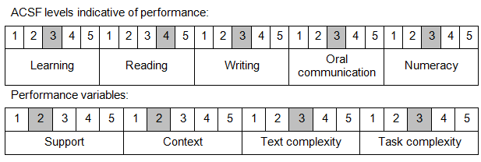

Further information on ACSF and the foundation skills underpinning this unit can be found in the Foundation Skills Guide on the GSA website.

Range of Conditions
Processes include: | - powdered activated carbon (PAC)  - granular activated carbon (GAC)  - biologically activated carbon (BAC)

Unit Mapping Information
No equivalent unit.

Links
Companion Volume implementation guides are found in VETNet - https://vetnet.education.gov.au/Pages/TrainingDocs.aspx?q=26336bc0-04e5-49d9-8c31-46c49b6a0037
Companion Volume implementation guides are found in VETNet - https://vetnet.education.gov.au/Pages/TrainingDocs.aspx?q=26336bc0-04e5-49d9-8c31-46c49b6a0037
Companion Volume implementation guides are found in VETNet - https://vetnet.education.gov.au/Pages/TrainingDocs.aspx?q=26336bc0-04e5-49d9-8c31-46c49b6a0037
Companion Volume implementation guides are found in VETNet - https://vetnet.education.gov.au/Pages/TrainingDocs.aspx?q=26336bc0-04e5-49d9-8c31-46c49b6a0037

