NWPTRT032 Assess and improve sedimentation processes
Release: 1

NWPTRT032 Assess and improve sedimentation processes

Modification History
Release | Comments
1 | This unit was released in NWP Water Training Package release 1.0 and meets the Standards for Training Packages.  This unit supersedes and is equivalent to NWP408A Investigate and plan the optimisation of sedimentation and clarification processes.  - Unit code updated  - Content and formatting updated to comply with the new standards  - All PC transitioned from passive to active voice  - Unit title changed to better reflect unit outcomes  - One new PC added to Element 2

Application
This unit describes the skills required to evaluate system performance and investigate and report on the optimisation of sedimentation and clarification processes.
This unit applies to those working as technical staff with responsibility for optimising sedimentation and clarification processes in water and wastewater treatment plants. This role may be performed as a single operator, or as part of a team with some responsibility for team coordination and supervision, depending on the size of the treatment plant.
The skills and knowledge described in this unit must be applied within the legislative, regulatory and policy environment in which they are carried out. Organisational policies and procedures must be consulted and adhered to.
Those undertaking this unit would work under indirect supervision, while performing complex tasks, within a familiar context.
No licensing, legislative or certification requirements apply to unit at the time of publication.

Competency Field
Treatment

Elements and Performance Criteria
ELEMENTS | PERFORMANCE CRITERIA
Elements describe the essential outcomes | Performance criteria describe the performance needed to demonstrate achievement of the element. Where bold italicised text is used, further information is detailed in the range of conditions section.
1. Assess sedimentation and clarification process performance | 1.1 Review existing process performance data.  1.2 Identify the impact of changing incoming water quality on sedimentation and clarification processes in a range of conditions.  1.3 Identify any additional sampling and testing required for valid evaluation of current process performance.
2. Investigate sedimentation and clarification assets | 2.1 Review existing fault reports and other plant asset information.  2.2 Investigate the operational status of plant components with reference to manufacturer and plant designer specifications.  2.3 Carry out investigations to identify potential deficiencies.
3. Investigate process optimisation | 3.1 Review relevant fault and incident reports and remedial actions taken.  3.2 Investigate potential changes to operational processes to identify possible optimisation strategies.
4. Plan process optimisation | 4.1 Determine plant configuration and revised operational processes for process optimisation.  4.2 Plan a trial to test the performance of the determined optimisation options.  4.3 Compile a report making recommendations on optimisation options.

Foundation Skills
The foundation skills demands of this unit have been mapped for alignment with the Australian Core Skills Framework (ACSF). The following tables outline the performance levels indicated for successful attainment of the unit.

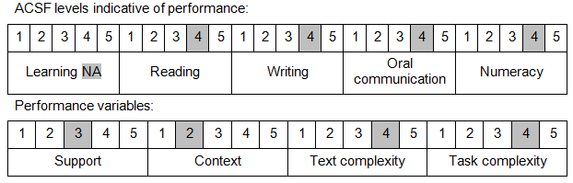

Further information on ACSF and the foundation skills underpinning this unit can be found in the Foundation Skills Guide on the GSA website.

Unit Mapping Information
This unit supersedes and is equivalent to NWP408A Investigate and plan the optimisation of sedimentation and clarification processes.

Links
Companion Volume implementation guides are found in VETNet - https://vetnet.gov.au/Pages/TrainingDocs.aspx?q=26336bc0-04e5-49d9-8c31-46c49b6a0037
Companion Volume implementation guides are found in VETNet - https://vetnet.gov.au/Pages/TrainingDocs.aspx?q=26336bc0-04e5-49d9-8c31-46c49b6a0037
Companion Volume implementation guides are found in VETNet - https://vetnet.gov.au/Pages/TrainingDocs.aspx?q=26336bc0-04e5-49d9-8c31-46c49b6a0037
Companion Volume implementation guides are found in VETNet - https://vetnet.gov.au/Pages/TrainingDocs.aspx?q=26336bc0-04e5-49d9-8c31-46c49b6a0037

