NWPTRT015 Operate and control coagulation and flocculation processes
Release: 1

NWPTRT015 Operate and control coagulation and flocculation processes

Modification History
Release | Comments
1 | This unit was released in NWP Water Training Package release 1.0 and meets the Standards for Training Packages.  This unit supersedes and is equivalent to NWP347B Monitor, operate and control coagulation and flocculation processes.  - Unit code updated  - Content and formatting updated to comply with the new standards  - All PC transitioned from passive to active voice  - Unit title changed to better reflect unit outcomes  - Two new PC added to Element 1

Application
This unit of competency describes the skills required to monitor, operate and control coagulation and flocculation processes; and to measure and report on system performance and quality control. The ability to identify faults, determine and apply technical adjustments and conduct chemical dosing procedures.
This unit applies to those working as operational staff with a specific responsibility for coagulation and flocculation processes in water and wastewater plants.
The skills and knowledge described in this unit must be applied within the legislative, regulatory, statutory and policy environment in which they are carried out. Organisational policies and procedures must be consulted and adhered to, particularly those relating to safety, water testing, chemical dosing, handling and storage of hazardous substances and dangerous goods.
Those undertaking this unit would work under supervision, while performing routine tasks, within a familiar context.
No licensing, legislative or certification requirements apply to unit at the time of publication.

Competency Field
Treatment

Elements and Performance Criteria
ELEMENTS | PERFORMANCE CRITERIA
Elements describe the essential outcomes | Performance criteria describe the performance needed to demonstrate achievement of the element. Where bold italicised text is used, further information is detailed in the range of conditions section.
1. Monitor coagulation and flocculation processes | 1.1 Monitor test results and processes to ensure compliance with the parameters of the operation.  1.2 Identify and report process faults and the operational condition of plant.  1.3 Collect and test samples.  1.4 Conduct jar tests and determine dosages.
2. Control chemical use | 2.1 Use, handle and store chemicals.  2.2 Determine and apply chemical dosing according to plant processes based on jar testing.  2.3 Maintain chemical supply and usage records.
3. Operate and control coagulation and flocculation processes | 3.1 Carry out routine plant inspections.  3.2 Collect process samples and conduct standard tests such as jar testing.  3.3 Carry out system adjustments and process calculations to improve system performance whenever water quality changes or process performance deteriorates.
4. Complete documentation | 4.1 Compile reports from plant and system data.  4.2 Report observations outside defined parameters for further action.

Foundation Skills
The foundation skills demands of this unit have been mapped for alignment with the Australian Core Skills Framework (ACSF). The following tables outline the performance levels indicated for successful attainment of the unit.

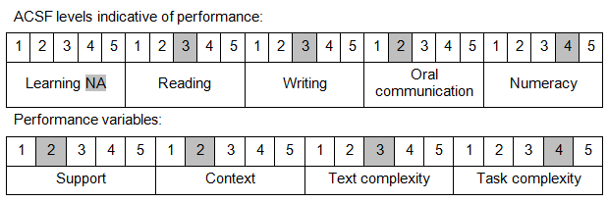

Further information on ACSF and the foundation skills underpinning this unit can be found in the Foundation Skills Guide on the GSA website.

Unit Mapping Information
This unit supersedes and is equivalent to NWP347B Monitor, operate and control coagulation and flocculation processes.

Links
Companion Volume implementation guides are found in VETNet - https://vetnet.education.gov.au/Pages/TrainingDocs.aspx?q=26336bc0-04e5-49d9-8c31-46c49b6a0037
Companion Volume implementation guides are found in VETNet - https://vetnet.education.gov.au/Pages/TrainingDocs.aspx?q=26336bc0-04e5-49d9-8c31-46c49b6a0037
Companion Volume implementation guides are found in VETNet - https://vetnet.education.gov.au/Pages/TrainingDocs.aspx?q=26336bc0-04e5-49d9-8c31-46c49b6a0037
Companion Volume implementation guides are found in VETNet - https://vetnet.education.gov.au/Pages/TrainingDocs.aspx?q=26336bc0-04e5-49d9-8c31-46c49b6a0037

