NWPTRT013 Operate and control liquefied chlorine gas disinfection
Release: 1

NWPTRT013 Operate and control liquefied chlorine gas disinfection

Modification History
Release | Comments
1 | This unit was released in NWP Water Training Package release 1.0 and meets the Standards for Training Packages.  - New unit, created drawing upon information from deleted unit NWP277A

Application
This unit describes the skills required to monitor and operate liquefied chlorine gas disinfection systems and report on process quality control whilst working safely. This includes being able to demonstrate correct use of self-contained breathing apparatus.
This unit applies to those working as operational staff with specific responsibility for disconnecting and connecting liquefied chlorine gas containers in water and wastewater treatment plants.
The skills and knowledge described in this unit must be applied within the legislative, regulatory and policy environment in which they are carried out. Organisational policies and procedures must be consulted and adhered to including WHS and handling dangerous goods.
Those undertaking this unit would work under supervision, while performing routine tasks, in a range of familiar contexts.
No licensing, legislative or certification requirements apply to unit at the time of publication.

Competency Field
Treatment

Elements and Performance Criteria
ELEMENTS | PERFORMANCE CRITERIA
Elements describe the essential outcomes | Performance criteria describe the performance needed to demonstrate achievement of the element. Where bold italicised text is used, further information is detailed in the range of conditions section.
1. Prepare to work with liquefied chlorine gas | 1.1 Check work procedures and instructions for compliance.  1.2 Check hazard signage for compliance.  1.3 Select and check tools and equipment.  1.4 Check first aid provisions for potential liquefied chlorine gas exposure hazards.  1.5 Select, fit and use personal protective equipment.
2. Perform liquefied chlorine gas container changeover procedures | 2.1 Obtain and handle liquefied chlorine gas containers from the correct storage area.  2.2 Conduct connection and disconnection procedures for chlorine gas draw or chlorine liquid draw systems.  2.3 Move depleted containers within storage area.  2.4 Check and store tools and equipment.
3. Monitor process performance | 3.1 Conduct and perform process tests and compare performance to process operational requirements.  3.2 Set critical control point dosing points according to organisation procedures.  3.3 Maintain and monitor relevant WHS requirements.  3.4 Make process adjustments as required to maintain effectiveness of the disinfection system.
4. Complete documentation | 4.1 Collect and record process data.  4.2 Report observations outside defined parameters for further action.

Foundation Skills
The foundation skills demands of this unit have been mapped for alignment with the Australian Core Skills Framework (ACSF). The following tables outline the performance levels indicated for successful attainment of the unit.

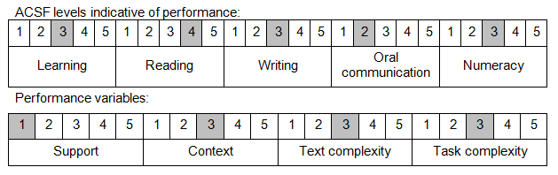

Further information on ACSF and the foundation skills underpinning this unit can be found in the Foundation Skills Guide on the GSA website.

Range of Conditions
Handling procedures include: | - transport and handling of liquefied chlorine gas containers  - container disconnection and connection procedures for chlorine gas or chlorine liquid draw systems  - storage of liquefied chlorine gas cylinders or drums
Types of chlorine draw include: | - liquid draw  - gas draw
Types of containers include: | - cylinders  - drums  - tanker deliveries

Unit Mapping Information
No equivalent unit.

Links
Companion Volume implementation guides are found in VETNet - https://vetnet.education.gov.au/Pages/TrainingDocs.aspx?q=26336bc0-04e5-49d9-8c31-46c49b6a0037
Companion Volume implementation guides are found in VETNet - https://vetnet.education.gov.au/Pages/TrainingDocs.aspx?q=26336bc0-04e5-49d9-8c31-46c49b6a0037
Companion Volume implementation guides are found in VETNet - https://vetnet.education.gov.au/Pages/TrainingDocs.aspx?q=26336bc0-04e5-49d9-8c31-46c49b6a0037
Companion Volume implementation guides are found in VETNet - https://vetnet.education.gov.au/Pages/TrainingDocs.aspx?q=26336bc0-04e5-49d9-8c31-46c49b6a0037

