NWPTRT012 Operate and control fluoride addition process
Release: 1

NWPTRT012 Operate and control fluoride addition process

Modification History
Release | Comments
1 | This unit was released in NWP Water Training Package release 1.0 and meets the Standards for Training Packages.  This unit supersedes and is equivalent to NWP276A Monitor, operate and report fluoridation systems.  - Unit code updated  - Content and formatting updated to comply with the new standards  - All PC transitioned from passive to active voice  - Unit title changed to better reflect unit outcomes.  - Element 4 reworded  - One new PC added to Element 3

Application
This unit describes the skills required to monitor and operate fluoridation processes and to report on water quality control.
This unit applies to those working as water operators responsible for fluoridation processes in water treatment. It may be a requirement for compliance with state and territory legislation and government water quality guidelines.
The skills and knowledge described in this unit must be applied within the legislative, regulatory and policy environment in which they are carried out. Organisational policies and procedures must be consulted and adhered to, particularly those relating to WHS.
Those undertaking this unit would work under supervision, while performing routine tasks, in a range of familiar contexts.
No licensing, legislative or certification requirements apply to unit at the time of publication.

Competency Field
Treatment

Elements and Performance Criteria
ELEMENTS | PERFORMANCE CRITERIA
Elements describe the essential outcomes | Performance criteria describe the performance needed to demonstrate achievement of the element. Where bold italicised text is used, further information is detailed in the range of conditions section.
1. Plan and prepare for work | 1.1 Determine work requirements.  1.2 Select and check equipment and tools required to meet safety requirements of task and site.  1.3 Select, fit and use personal protective equipment.
2. Monitor process performance | 2.1 Monitor fluoridation processes.  2.2 Collect process samples and conduct standard tests.  2.3 Maintain and monitor relevant WHS requirements.  2.4 Collect and record process data and perform calculations.
3. Prepare and apply fluoride dosing | 3.1 Handle, use and store fluoridation chemicals.  3.2 Apply fluoride dosing and perform calculations.  3.3 Monitor fluoride levels.
4. Complete documentation | 4.1 Maintain information relating to fluoride supply and usage.  4.2 Produce information relating to maintenance and operation.  4.3 Record information and submit for continuous improvement and incident management.

Foundation Skills
The foundation skills demands of this unit have been mapped for alignment with the Australian Core Skills Framework (ACSF). The following tables outline the performance levels indicated for successful attainment of the unit.

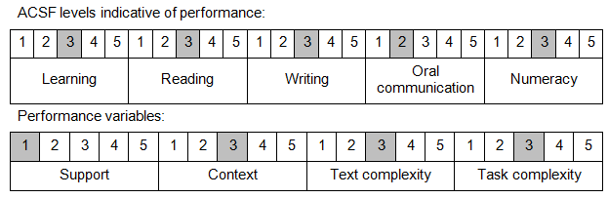

Further information on ACSF and the foundation skills underpinning this unit can be found in the Foundation Skills Guide on the GSA website.

Range of Conditions
Types of fluoridation processes: | - sodium fluoride  - fluorosilicic acid  - sodium fluorosilicate

Unit Mapping Information
This unit supersedes and is equivalent to NWP276A Monitor, operate and report fluoridation systems.

Links
Companion Volume implementation guides are found in VETNet - https://vetnet.gov.au/Pages/TrainingDocs.aspx?q=26336bc0-04e5-49d9-8c31-46c49b6a0037
Companion Volume implementation guides are found in VETNet - https://vetnet.gov.au/Pages/TrainingDocs.aspx?q=26336bc0-04e5-49d9-8c31-46c49b6a0037
Companion Volume implementation guides are found in VETNet - https://vetnet.gov.au/Pages/TrainingDocs.aspx?q=26336bc0-04e5-49d9-8c31-46c49b6a0037
Companion Volume implementation guides are found in VETNet - https://vetnet.gov.au/Pages/TrainingDocs.aspx?q=26336bc0-04e5-49d9-8c31-46c49b6a0037

