NWPTRT011 Assess and improve chemical dosing process
Release: 1

NWPTRT011 Assess and improve chemical dosing process

Modification History
Release | Comments
1 | This unit was released in NWP Water Training Package release 1.0 and meets the Standards for Training Packages.  This unit supersedes and is equivalent to NWP409A Investigate and plan to optimise the operation of chemical addition processes.  - Unit code updated  - Content and formatting updated to comply with the new standards  - All PC transitioned from passive to active voice  - Unit title changed to better reflect unit outcomes  - Element 1 reworded

Application
This unit describes the skills required to review, coordinate and optimise chemical addition processes and to evaluate and report on system performance and process quality control.
This unit applies to those working as technical staff with a responsibility for optimising chemical addition processes in water, wastewater and stormwater treatment plants and processes.
The skills and knowledge described in this unit must be applied within the legislative, regulatory and policy environment in which they are carried out. Organisational policies and procedures must be consulted and adhered to, particularly those relating to manufacturer and plant designer specifications, dosing pump capacity and calibration chart.
Those undertaking this unit would work as single operator or as part of a team with some responsibility for team coordination and supervision, depending on the size of the treatment plant. They would perform complex tasks within a familiar context.
No licensing, legislative or certification requirements apply to unit at the time of publication.

Competency Field
Treatment

Elements and Performance Criteria
ELEMENTS | PERFORMANCE CRITERIA
Elements describe the essential outcomes | Performance criteria describe the performance needed to demonstrate achievement of the element. Where bold italicised text is used, further information is detailed in the range of conditions section.
1. Evaluate chemical addition process performance | 1.1 Review existing process performance data against relevant organisational and legislative requirements.  1.2 Identify the impact of changing raw or influent water quality on chemical addition processes.  1.3 Identify and coordinate any additional sampling and testing required for valid evaluation of current process performance.
2. Investigate chemical addition plant configuration | 2.1 Review existing fault reports and other plant asset information.  2.2 Investigate the operational status of plant components with reference to manufacturer and plant designer specifications.  2.3 Carry out plant configuration investigations to identify potential deficiencies.
3. Investigate chemical options for process optimisation | 3.1 Review current chemical addition practices with reference to organisational procedures to identify potential deficiencies.  3.2 Investigate dosing options for current chemicals.  3.3 Identify and investigate new or additional chemicals and related dosing options.
4. Develop and record a plan for process optimisation | 4.1 Determine plant configuration or chemical options for process optimisation.  4.2 Plan a trial to test the performance of the determined optimisation options.  4.3 Compile report with recommendations on optimisation options.

Foundation Skills
The foundation skills demands of this unit have been mapped for alignment with the Australian Core Skills Framework (ACSF). The following tables outline the performance levels indicated for successful attainment of the unit.

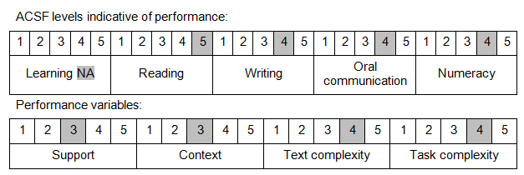

Further information on ACSF and the foundation skills underpinning this unit can be found in the Foundation Skills Guide on the GSA website.

Unit Mapping Information
This unit supersedes and is equivalent to NWP409A Investigate and plan to optimise the operation of chemical addition processes.

Links
Companion Volume implementation guides are found in VETNet - https://vetnet.gov.au/Pages/TrainingDocs.aspx?q=26336bc0-04e5-49d9-8c31-46c49b6a0037
Companion Volume implementation guides are found in VETNet - https://vetnet.gov.au/Pages/TrainingDocs.aspx?q=26336bc0-04e5-49d9-8c31-46c49b6a0037
Companion Volume implementation guides are found in VETNet - https://vetnet.gov.au/Pages/TrainingDocs.aspx?q=26336bc0-04e5-49d9-8c31-46c49b6a0037
Companion Volume implementation guides are found in VETNet - https://vetnet.gov.au/Pages/TrainingDocs.aspx?q=26336bc0-04e5-49d9-8c31-46c49b6a0037

