NWPTRT001 Operate and control water treatment processes
Release: 1

NWPTRT001 Operate and control water treatment processes

Modification History
Release | Comments
1 | This unit was released in NWP Water Training Package release 1.0 and meets the Standards for Training Packages.  - New unit, created drawing upon information from deleted units NWP260A, NWP261A and NWP345B

Application
This unit of competency describes the skills required to operate and control a water treatment plant, to report on water treatment plant system performance and process quality control. The ability to operate water treatment processes in urban and/or rural areas, in compliance with relevant water legislation and regulations and Australian Drinking Water Guidelines, is vital to performance.
This unit applies to those working as operational staff in water treatment plants with responsibility for the practical and safe operation of plant, equipment and processes.
The skills and knowledge described in this unit must be applied within the legislative, statutory, regulatory and policy environment in which they are carried out. Organisational policies and procedures must be consulted and adhered to.
Those undertaking this unit would work under supervision, while performing routine tasks, within a familiar context.
No licensing, legislative or certification requirements apply to unit at the time of publication.

Competency Field
Treatment

Elements and Performance Criteria
ELEMENTS | PERFORMANCE CRITERIA
Elements describe the essential outcomes | Performance criteria describe the performance needed to demonstrate achievement of the element. Where bold italicised text is used, further information is detailed in the range of conditions section.
1. Plan and prepare for work | 1.1 Determine work requirements from job specifications and plans.  1.2 Select and check equipment to meet safety requirements of task and site.  1.3 Select, fit and use safety equipment including personal protective equipment.
2. Operate and control process | 2.1 Carry out routine plant inspections according to the type of plant.  2.2 Identify and report process faults and the operational condition of the plant.  2.3 Collect samples and conduct standard tests.  2.4 Carry out basic adjustments to improve process performance.
3. Complete documentation | 3.1 Collect, interpret, record and complete process data.  3.2 Identify data that falls outside normal parameters and report for further action.

Foundation Skills
The foundation skills demands of this unit have been mapped for alignment with the Australian Core Skills Framework (ACSF). The following tables outline the performance levels indicated for successful attainment of the unit.

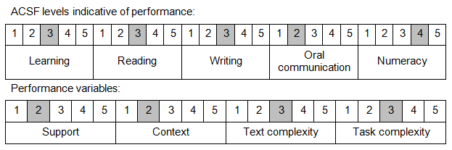

Further information on ACSF and the foundation skills underpinning this unit can be found in the Foundation Skills Guide on the GSA website.

Range of Conditions
Current processes include: | - pre-treatment  - chemical dosing  - coagulation  - pH adjustment  - iron manganese  - pre-screening  - separation  - clarification  - filtration  - DAF  - disinfection  - post-treatment  - fluoride  - ozone  - BAC  - stabilisation

Unit Mapping Information
No equivalent unit.

Links
Companion Volume implementation guides are found in VETNet - https://vetnet.gov.au/Pages/TrainingDocs.aspx?q=26336bc0-04e5-49d9-8c31-46c49b6a0037
Companion Volume implementation guides are found in VETNet - https://vetnet.gov.au/Pages/TrainingDocs.aspx?q=26336bc0-04e5-49d9-8c31-46c49b6a0037
Companion Volume implementation guides are found in VETNet - https://vetnet.gov.au/Pages/TrainingDocs.aspx?q=26336bc0-04e5-49d9-8c31-46c49b6a0037
Companion Volume implementation guides are found in VETNet - https://vetnet.gov.au/Pages/TrainingDocs.aspx?q=26336bc0-04e5-49d9-8c31-46c49b6a0037

