NWPTRD022 Develop and modify trade waste policies and plans
Release: 1

NWPTRD022 Develop and modify trade waste policies and plans

Modification History
Release | Comments
1 | This unit was released in NWP Water Training Package release 1.0 and meets the Standards for Training Packages.  This unit supersedes and is equivalent to NWP529B Develop and modify trade waste management policies and plans.  - Unit code updated  - Content and formatting updated to comply with the new standards  - All PC transitioned from passive to active voice  - Unit title changed to better reflect unit outcomes  - PC 3.5 removed

Application
This unit of competency describes the skills required to develop and modify policies and plans for trade waste activities relating to liquid waste discharge to wastewater collection systems.

This unit applies to those working as managers in water organisations with responsibility for the management of trade waste policies and plans.

The skills and knowledge described in this unit must be applied within the legislative, regulatory and policy environment in which they are carried out. Organisational policies and procedures must be consulted and adhered to.

Those undertaking this unit would work autonomously, supervising staff, while performing sophisticated tasks in a range of familiar contexts.

No licensing, legislative or certification requirements apply to unit at the time of publication.

Competency Field
Trade waste

Elements and Performance Criteria
ELEMENTS | PERFORMANCE CRITERIA
Elements describe the essential outcomes | Performance criteria describe the performance needed to demonstrate achievement of the element. Where bold italicised text is used, further information is detailed in the range of conditions section.
1. Prepare and plan for trade waste management | 1.1 Identify and define relevant provisions of trade waste management legislation, standards and enterprise policies.  1.2 Document trade waste management policies, procedures and programs.  1.3 Identify significant wastewater quality parameters generated by major industries.  1.4 Consider information about known impacts, risk assessments and control procedures in preparing plans.  1.5 Define and explain responsibilities and accountabilities.
2. Develop or modify trade waste management policies and plans | 2.1 Conduct community, enterprise and stakeholder consultation.  2.2 Address issues raised through consultation and incorporate them into the policy development, where appropriate.  2.3 Identify and explain trade waste management processes including treatment and disposal processes together with the required workplace procedures and relevant environmental factors.  2.4 Develop and modify contingency plans for major trade waste industries.  2.5 Include issues identified by reviews and audits into the management plan.  2.6 Prepare and present management policies and plans.
3. Review and refine trade waste management policies and plans | 3.1 Review management policies against established objectives, policies and plans.  3.2 Review policies and plans through consultation, against prevailing stakeholder expectations.  3.3 Modify policies and plans to include identified and required changes.  3.4 Benchmark policies, management systems and plans with other water utilities.

Foundation Skills
The foundation skills demands of this unit have been mapped for alignment with the Australian Core Skills Framework (ACSF). The following tables outline the performance levels indicated for successful attainment of the unit.

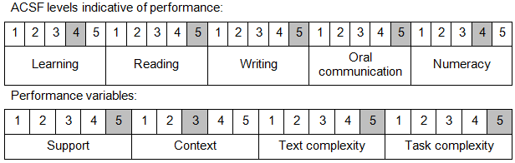

Further information on ACSF and the foundation skills underpinning this unit can be found in the Foundation Skills Guide on the GSA website.

Unit Mapping Information
This unit supersedes and is equivalent to NWP529B Develop and modify trade waste management policies and plans.

Links
GSA website - http://www.govskills.com.au
NWP Implementation Guide - http://www.govskills.com.au/guides/water/implementation-guide
NWP Foundation Skills Guide - http://www.govskills.com.au/guides/water/foundation-skills-guide
NWP Knowledge Guide - http://www.govskills.com.au/guides/water/knowledge-guide

