NWPTRD011 Investigate and report on breaches of water industry legislation
Release: 1

NWPTRD011 Investigate and report on breaches of water industry legislation

Modification History
Release | Comments
1 | This unit was released in NWP Water Training Package release 1.0 and meets the Standards for Training Packages.  This unit supersedes and is equivalent to NWP315B Investigate and report breaches of water industry legislation.  - Unit code updated  - Content and formatting updated to comply with the new standards  - All PC transitioned from passive to active voice  - Unit title changed to better reflect unit outcomes  - PC 2.3 revised

Application
This unit describes the skills required to investigate breaches of legislation relevant to the water industry, including conducting interviews and preparing reports for use in court proceedings.
This unit applies to those working in the water industry with a specific responsibility for enforcing water industry legislation, including local by-laws and the Water Act.
The skills and knowledge described in this unit must be applied within the legislative, regulatory and policy environment in which they are carried out. Organisational policies and procedures must be consulted and adhered to, particularly those related to water industry legislation.
Those undertaking this unit would work independently, while performing complex tasks, in a broad range of contexts.
No licensing, legislative or certification requirements apply to unit at the time of publication.

Competency Field
Trade waste

Elements and Performance Criteria
ELEMENTS | PERFORMANCE CRITERIA
Elements describe the essential outcomes | Performance criteria describe the performance needed to demonstrate achievement of the element. Where bold italicised text is used, further information is detailed in the range of conditions section.
1. Investigate breach of legislation | 1.1 Identify and investigate breaches of legislation.  1.2 Collect and collate information about breach of legislation.
2. Notify breaches to relevant parties | 2.1 Issue notification of breach of legislation to subjects.  2.2 Interview subjects and recommend remedial action or further action.  2.3 Record and collate interview notes and information.
3. Prepare reports and records | 3.1 Prepare clear and concise reports for use in court proceedings according to stakeholder and organisational requirements.  3.2 Recommend action according to design specifications and organisational requirements.

Foundation Skills
The foundation skills demands of this unit have been mapped for alignment with the Australian Core Skills Framework (ACSF). The following tables outline the performance levels indicated for successful attainment of the unit.

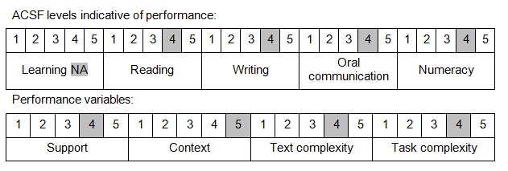

Further information on ACSF and the foundation skills underpinning this unit can be found in the Foundation Skills Guide on the GSA website.

Unit Mapping Information
This unit supersedes and is equivalent to NWP315B Investigate and report breaches of water industry legislation.

Links
Companion Volume implementation guides are found in VETNet - https://vetnet.education.gov.au/Pages/TrainingDocs.aspx?q=26336bc0-04e5-49d9-8c31-46c49b6a0037
Companion Volume implementation guides are found in VETNet - https://vetnet.education.gov.au/Pages/TrainingDocs.aspx?q=26336bc0-04e5-49d9-8c31-46c49b6a0037
Companion Volume implementation guides are found in VETNet - https://vetnet.education.gov.au/Pages/TrainingDocs.aspx?q=26336bc0-04e5-49d9-8c31-46c49b6a0037
Companion Volume implementation guides are found in VETNet - https://vetnet.education.gov.au/Pages/TrainingDocs.aspx?q=26336bc0-04e5-49d9-8c31-46c49b6a0037

