NWPSOU054 Monitor and operate pump stations
Release: 1

NWPSOU054 Monitor and operate pump stations

Modification History
Release | Comments
1 | This unit was released in NWP Water Training Package release 1.0 and meets the Standards for Training Packages.  This unit supersedes and is equivalent to NWP259B Operate, monitor and maintain pump stations.  - Unit code updated  - Content and formatting updated to comply with the new standards  - All PC transitioned from passive to active voice  - Unit title changed to better reflect unit outcomes  - PC 1.2 and 3.1 removed  - PC 1.4 revised  - PC 3.3 and 3.4 merged

Application
This unit describes the skills required to operate and monitor the performance of pump stations in water and wastewater systems and undertake minor maintenance, or organise more complex maintenance, of pump stations. This may include minor maintenance tasks, including gland adjustment, packing replacement and the replacement of some fittings.
This unit applies to those working as staff with specific responsibility for ensuring that pump stations operate according to organisational requirements.
The skills and knowledge described in this unit must be applied within the legislative, regulatory and policy environment in which they are carried out. Organisational policies and procedures must be consulted and adhered to, particularly those related to WHS, maintenance standards and manufacturer specifications.
Those undertaking this unit would work under indirect supervision, while performing routine tasks in a familiar context, ensuring minimal damage to the environment.
No licensing, legislative or certification requirements apply to unit at the time of publication.

Competency Field
Source

Elements and Performance Criteria
ELEMENTS | PERFORMANCE CRITERIA
Elements describe the essential outcomes | Performance criteria describe the performance needed to demonstrate achievement of the element. Where bold italicised text is used, further information is detailed in the range of conditions section.
1. Plan and prepare work | 1.1 Determine pump station work requirements from standard operating and maintenance procedures.  1.2 Perform site check to prevent damage to other utilities and the environment.  1.3 Select and check equipment to meet safety requirements of task and site.  1.4 Select, fit and use personal protective equipment.  1.5 Handle, use and store chemicals.
2. Operate pump stations | 2.1 Identify and set or adjust pump station components.  2.2 Carry out routine security inspections and cleaning duties.  2.3 Operate pump station.
3. Maintain pump stations | 3.1 Inspect pump station components and identify maintenance needs.  3.2 Schedule maintenance tasks, order appropriate materials and conduct maintenance tasks.  3.3 Identify and report pump station faults and carry out minor repairs.
4. Monitor and adjust pump station performance | 4.1 Apply pump station performance targets.  4.2 Identify and apply monitoring points and timing.  4.3 Monitor pump station and adjust, where necessary, to maintain operational parameters.
5. Check outsourced maintenance work | 5.1 Check that completed maintenance and repairs meet specifications.  5.2 Check return of pumping station to service.
6. Finalise work | 6.1 Check, maintain and store equipment, tools and materials.  6.2 Restore work site.  6.3 Maintain workplace records as required.

Foundation Skills
The foundation skills demands of this unit have been mapped for alignment with the Australian Core Skills Framework (ACSF). The following tables outline the performance levels indicated for successful attainment of the unit.

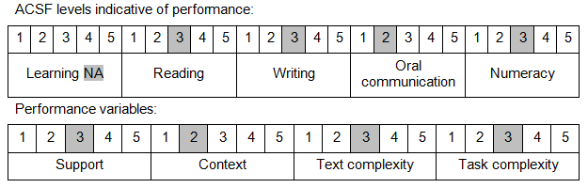

Further information on ACSF and the foundation skills underpinning this unit can be found in the Foundation Skills Guide on the GSA website.

Unit Mapping Information
This unit supersedes and is equivalent to NWP259B Operate, monitor and maintain pump stations.

Links
Companion Volume implementation guides are found in VETNet - https://vetnet.gov.au/Pages/TrainingDocs.aspx?q=26336bc0-04e5-49d9-8c31-46c49b6a0037
Companion Volume implementation guides are found in VETNet - https://vetnet.gov.au/Pages/TrainingDocs.aspx?q=26336bc0-04e5-49d9-8c31-46c49b6a0037
Companion Volume implementation guides are found in VETNet - https://vetnet.gov.au/Pages/TrainingDocs.aspx?q=26336bc0-04e5-49d9-8c31-46c49b6a0037
Companion Volume implementation guides are found in VETNet - https://vetnet.gov.au/Pages/TrainingDocs.aspx?q=26336bc0-04e5-49d9-8c31-46c49b6a0037

