NWPSOU051 Monitor and operate groundwater extraction
Release: 1

NWPSOU051 Monitor and operate groundwater extraction

Modification History
Release | Comments
1 | This unit was released in NWP Water Training Package release 1.0 and meets the Standards for Training Packages.  - New unit, created drawing upon information from deleted units NWP242B and NWP243B

Application
This unit describes the skills required to monitor the extraction of water from waterways and water bodies and to report risks, compliance and complaints. This includes operating pumps and meters. Skills to moniter the availability and quality of supply and control of water flows from the source are also required, in conjunction with the ability to apply legislative and organisational requirements.
This unit applies to those working as field staff with responsibility for ensuring that water extraction complies with water use legislation.
The skills and knowledge described in this unit must be applied within the legislative, regulatory and policy environment in which they are carried out. Organisational policies and procedures must be consulted and adhered to.
Those undertaking this unit would work under supervision, while performing routine tasks in range of familiar contexts.
No licensing, legislative or certification requirements apply to unit at the time of publication.

Competency Field
Source

Elements and Performance Criteria
ELEMENTS | PERFORMANCE CRITERIA
Elements describe the essential outcomes | Performance criteria describe the performance needed to demonstrate achievement of the element. Where bold italicised text is used, further information is detailed in the range of conditions section.
1. Prepare for work | 1.1 Interpret relevant legislation and organisational rules and requirements.  1.2 Locate bore sites from plans and job specifications.  1.3 Schedule and plan inspection.  1.4 Select, check and prepare basic equipment to monitor water extraction.
2. Monitor and operate groundwater extraction systems | 2.1 Monitor designated locations within groundwater source area according to agreed schedule.  2.2 Conduct inspection taking readings of meters for water depth and water quality.  2.3 Check the integrity of assets.  2.4 Collect samples.  2.5 Make adjustments to flows when required.  2.6 Identify breaches of legislative and organisational requirements.
3. Identify and report risks, breaches and complaints | 3.1 Identify risks to public, users and environment.  3.2 Identify and report breaches of relevant legislation.  3.3 Investigate and report complaints from the public and users regarding water allocation and quality.

Foundation Skills
The foundation skills demands of this unit have been mapped for alignment with the Australian Core Skills Framework (ACSF). The following tables outline the performance levels indicated for successful attainment of the unit.

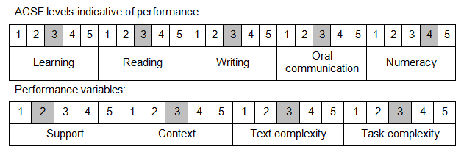

Further information on ACSF and the foundation skills underpinning this unit can be found in the Foundation Skills Guide on the GSA website.

Unit Mapping Information
No equivalent unit.

Links
Companion Volume implementation guides are found in VETNet - https://vetnet.gov.au/Pages/TrainingDocs.aspx?q=26336bc0-04e5-49d9-8c31-46c49b6a0037
Companion Volume implementation guides are found in VETNet - https://vetnet.gov.au/Pages/TrainingDocs.aspx?q=26336bc0-04e5-49d9-8c31-46c49b6a0037
Companion Volume implementation guides are found in VETNet - https://vetnet.gov.au/Pages/TrainingDocs.aspx?q=26336bc0-04e5-49d9-8c31-46c49b6a0037
Companion Volume implementation guides are found in VETNet - https://vetnet.gov.au/Pages/TrainingDocs.aspx?q=26336bc0-04e5-49d9-8c31-46c49b6a0037

