NWPSOU041 Coordinate and monitor bulkwater system operations
Release: 1

NWPSOU041 Coordinate and monitor bulkwater system operations

Modification History
Release | Comments
1 | This unit was released in NWP Water Training Package release 1.0 and meets the Standards for Training Packages.  This unit supersedes and is equivalent to NWP418B Coordinate and monitor bulkwater system operations.  - Unit code updated  - Content and formatting updated to comply with the new standards  - All PC transitioned from passive to active voice  - Element 4 reworded  - Elements 2 and 3 merged  - PC 1.2 and 1.3 merged

Application
This unit describes the skills required to monitor and coordinate the operation of bulkwater systems, to measure and report on system performance and process quality control.
This unit applies to workers responsible for ensuring that bulkwater system operations are coordinated and monitored to ensure compliance with organisational and statutory requirements.
The skills and knowledge described in this unit must be applied within the legislative, regulatory and policy environment in which they are carried out. Organisational policies and procedures must be consulted and adhered to.
Those undertaking this unit would work independently or in a team, and may coordinate an operational team. They would perform complex tasks in mostly familiar contexts while ensuring minimum damage to the environment.
No licensing, legislative or certification requirements apply to unit at the time of publication.

Competency Field
Source

Elements and Performance Criteria
ELEMENTS | PERFORMANCE CRITERIA
Elements describe the essential outcomes | Performance criteria describe the performance needed to demonstrate achievement of the element. Where bold italicised text is used, further information is detailed in the range of conditions section.
1. Confirm performance measures | 1.1 Identify water flow, quality and quantity requirements.  1.2 Identify surveillance and stakeholder requirements.  1.3 Identify performance measures for the resource and operation.  1.4 Identify environmental flows that impact on water flows and quality.
2. Monitor and coordinate asset performance | 2.1 Select, fit and use equipment, including personal protective equipment.  2.2 Apply monitoring and testing programs.  2.3 Monitor assets to ensure performance meets specifications in management plan.  2.4 Schedule maintenance programs.  2.5 Monitor water flows and quality.  2.6 Coordinate processes to meet plan requirements and targets.  2.7 Take action to optimise system performance.
3. Finalise work | 3.1 Analyse, record and report coordination and monitoring data.  3.2 Identify and report current and potential problems.

Foundation Skills
The foundation skills demands of this unit have been mapped for alignment with the Australian Core Skills Framework (ACSF). The following tables outline the performance levels indicated for successful attainment of the unit.

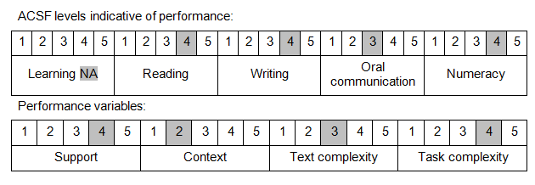

Further information on ACSF and the foundation skills underpinning this unit can be found in the Foundation Skills Guide on the GSA website.

Unit Mapping Information
This unit supersedes and is equivalent to NWP418B Coordinate and monitor bulkwater system operations.

Links
Companion Volume implementation guides are found in VETNet - https://vetnet.gov.au/Pages/TrainingDocs.aspx?q=26336bc0-04e5-49d9-8c31-46c49b6a0037
Companion Volume implementation guides are found in VETNet - https://vetnet.gov.au/Pages/TrainingDocs.aspx?q=26336bc0-04e5-49d9-8c31-46c49b6a0037
Companion Volume implementation guides are found in VETNet - https://vetnet.gov.au/Pages/TrainingDocs.aspx?q=26336bc0-04e5-49d9-8c31-46c49b6a0037
Companion Volume implementation guides are found in VETNet - https://vetnet.gov.au/Pages/TrainingDocs.aspx?q=26336bc0-04e5-49d9-8c31-46c49b6a0037

