NWPSOU032 Operate and maintain fishways
Release: 1

NWPSOU032 Operate and maintain fishways

Modification History
Release | Comments
1 | This unit was released in NWP Water Training Package release 1.0 and meets the Standards for Training Packages.

Application
This unit describes the skills required to operate and maintain automated and manual fishways by regulating flows into fishway channels, including handling and disposing of fish.
This unit applies to field staff with the responsibility for operating fishways in remote locations.
The skills and knowledge described in this unit must be applied within the legislative, regulatory and policy environment in which they are carried out. Organisational policies and procedures must be consulted and adhered to.
Those undertaking this unit will work independently under indirect supervision while performing routine tasks in a range of familiar contexts.
No licensing, legislative or certification requirements apply to unit at the time of publication.

Competency Field
Source

Elements and Performance Criteria
ELEMENTS | PERFORMANCE CRITERIA
Elements describe the essential outcomes | Performance criteria describe the performance needed to demonstrate achievement of the element. Where bold italicised text is used, further information is detailed in the range of conditions section.
1. Plan and prepare work | 1.1 Determine and apply the operational rules for the fishways from design reports.  1.2 Perform site check to establish upstream flows coming into the weir.  1.3 Plan gate opening and gate operations.  1.4 Develop plans for the maintenance of the fishways.
2. Operate the fishways | 2.1 Regulate weir and fishway gates to maintain fish attraction flows.  2.2 Identify, sort and record fish species and numbers.  2.3 Collect samples and test for temperature, DO, pH and conductivity.  2.4 Release native fish into weir pool and dispose of noxious fish.
3. Maintain the fishways | 3.1 Inspect the fishway channel, gates, baffles and cage to identify maintenance needs.  3.2 Test equipment and schedule maintenance tasks.
4. Finalise work | 4.1 Monitor and record water flow.  4.2 Collect fishway data from inspections and monitoring points.  4.3 Compile reports from the fishway data.

Foundation Skills
The foundation skills demands of this unit have been mapped for alignment with the Australian Core Skills Framework (ACSF). The following tables outline the performance levels indicated for successful attainment of the unit.

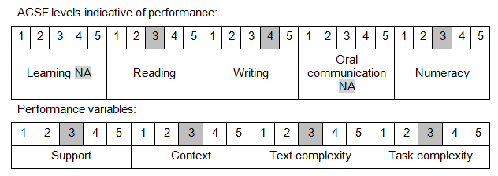

Further information on ACSF and the foundation skills underpinning this unit can be found in the Foundation Skills Guide on the GSA website.

Unit Mapping Information
No equivalent unit.

Links
Companion Volume implementation guides are found in VETNet - https://vetnet.education.gov.au/Pages/TrainingDocs.aspx?q=26336bc0-04e5-49d9-8c31-46c49b6a0037
Companion Volume implementation guides are found in VETNet - https://vetnet.education.gov.au/Pages/TrainingDocs.aspx?q=26336bc0-04e5-49d9-8c31-46c49b6a0037
Companion Volume implementation guides are found in VETNet - https://vetnet.education.gov.au/Pages/TrainingDocs.aspx?q=26336bc0-04e5-49d9-8c31-46c49b6a0037
Companion Volume implementation guides are found in VETNet - https://vetnet.education.gov.au/Pages/TrainingDocs.aspx?q=26336bc0-04e5-49d9-8c31-46c49b6a0037

