NWPSOU031 Operate and maintain locks and weirs
Release: 1

NWPSOU031 Operate and maintain locks and weirs

Modification History
Release | Comments
1 | This unit was released in NWP Water Training Package release 1.0 and meets the Standards for Training Packages.

Application
This unit describes the skills required to regulate flows through the weir and operate the lock gates.
This unit applies to those working as field staff with the responsibility for operating locks and weirs in remote locations.
The skills and knowledge described in this unit must be applied within the legislative, regulatory and policy environment in which they are carried out. Organisational policies and procedures must be consulted and adhered to.
Those undertaking this unit will work independently under indirect supervision while performing routine tasks in a range of familiar contexts.
No licensing, legislative or certification requirements apply to unit at the time of publication.

Competency Field
Source

Elements and Performance Criteria
ELEMENTS | PERFORMANCE CRITERIA
Elements describe the essential outcomes | Performance criteria describe the performance needed to demonstrate achievement of the element. Where bold italicised text is used, further information is detailed in the range of conditions section.
1. Plan and prepare work | 1.1 Assess upstream flow and establish pool demand.  1.2 Carry out inflow calculations.  1.3 Determine discharge flows.  1.4 Develop operation and maintenance plan.
2. Operate locks and weirs | 2.1 Operate the weir gates to control river flows and pool levels.  2.2 Store water in the weir pool and regulate river flow downstream.  2.3 Raise river level upstream of the weir to improve navigability of the river.  2.4 Operate the lock to allow river vessels to navigate through the weir.
3. Maintain locks and weirs | 3.1 Inspect the equipment of the locks, weirs and navigational aids to identify maintenance needs.  3.2 Schedule maintenance tasks.
4. Finalise work | 4.1 Collect data from monitoring points.  4.2 Compile reports from monitoring point data.  4.3 Identify and report current or potential problems.

Foundation Skills
The foundation skills demands of this unit have been mapped for alignment with the Australian Core Skills Framework (ACSF). The following tables outline the performance levels indicated for successful attainment of the unit.

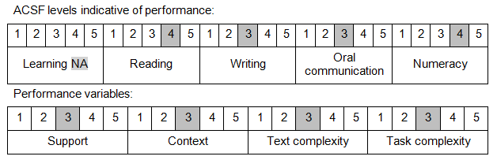

Further information on ACSF and the foundation skills underpinning this unit can be found in the Foundation Skills Guide on the GSA website.

Unit Mapping Information
No equivalent unit.

Links
Companion Volume implementation guides are found in VETNet - https://vetnet.education.gov.au/Pages/TrainingDocs.aspx?q=26336bc0-04e5-49d9-8c31-46c49b6a0037
Companion Volume implementation guides are found in VETNet - https://vetnet.education.gov.au/Pages/TrainingDocs.aspx?q=26336bc0-04e5-49d9-8c31-46c49b6a0037
Companion Volume implementation guides are found in VETNet - https://vetnet.education.gov.au/Pages/TrainingDocs.aspx?q=26336bc0-04e5-49d9-8c31-46c49b6a0037
Companion Volume implementation guides are found in VETNet - https://vetnet.education.gov.au/Pages/TrainingDocs.aspx?q=26336bc0-04e5-49d9-8c31-46c49b6a0037

