NWPSOU028 Prepare and report on data related to flood operations
Release: 1

NWPSOU028 Prepare and report on data related to flood operations

Modification History
Release | Comments
1 | This unit was released in NWP Water Training Package release 1.0 and meets the Standards for Training Packages.  - New unit, created drawing upon information from deleted units NWP518B and NWP519B

Application
This unit describes the skills required to analyse and model data relating to flooding, develop effective management and warning systems, and communicate the outcomes concisely and effectively.
This unit applies to those working as planners and managers in water organisations with responsibility for the preparation of flood management strategies and flood warning systems.
The skills and knowledge described in this unit must be applied within the legislative, regulatory and policy environment in which they are carried out. Organisational policies and procedures must be consulted and adhered to.
Those undertaking this unit would work autonomously with management responsibilities, while performing complex tasks in familiar contexts.
No licensing, legislative or certification requirements apply to unit at the time of publication.

Competency Field
Source

Elements and Performance Criteria
ELEMENTS | PERFORMANCE CRITERIA
Elements describe the essential outcomes | Performance criteria describe the performance needed to demonstrate achievement of the element. Where bold italicised text is used, further information is detailed in the range of conditions section.
1. Analyse rainfall and run-off regimes | 1.1 Access and interpret historical rainfall run-off and flooding regimes of specific catchments.  1.2 Study records to determine previous rainfall amounts, durations and time taken to reach catchment.  1.3 Model simulated, hypothetical or estimated rainfall intensity data and model catchment.  1.4 Collate, manipulate and interpret data.
2. Estimate flooding | 2.1 Estimate and record flood levels, extents and flow rates using organisational techniques and guidelines.  2.2 Assess and record flood hazard.
3. Determine management and warning systems | 3.1 Evaluate the roles of storage and/or retarding basins safety and flood attenuation strategies.  3.2 Evaluate current flood classifications and impacts.  3.3 Formulate planning controls for flood plain or waterway management.  3.4 Evaluate current flood warning systems.  3.5 Recommend or develop changes to existing flood plain or waterway management controls and warning systems.
4. Report and communicate recommendations | 4.1 Collate, analyse and record information.  4.2 Prepare and present reports.  4.3 Communicate findings and recommendations to stakeholders.

Foundation Skills
The foundation skills demands of this unit have been mapped for alignment with the Australian Core Skills Framework (ACSF). The following tables outline the performance levels indicated for successful attainment of the unit.

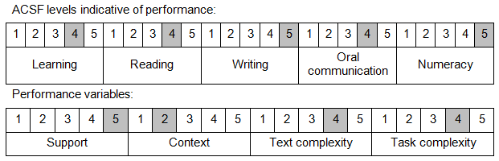

Further information on ACSF and the foundation skills underpinning this unit can be found in the Foundation Skills Guide on the GSA website.

Unit Mapping Information
No equivalent unit.

Links
Companion Volume implementation guides are found in VETNet - https://vetnet.education.gov.au/Pages/TrainingDocs.aspx?q=26336bc0-04e5-49d9-8c31-46c49b6a0037
Companion Volume implementation guides are found in VETNet - https://vetnet.education.gov.au/Pages/TrainingDocs.aspx?q=26336bc0-04e5-49d9-8c31-46c49b6a0037
Companion Volume implementation guides are found in VETNet - https://vetnet.education.gov.au/Pages/TrainingDocs.aspx?q=26336bc0-04e5-49d9-8c31-46c49b6a0037
Companion Volume implementation guides are found in VETNet - https://vetnet.education.gov.au/Pages/TrainingDocs.aspx?q=26336bc0-04e5-49d9-8c31-46c49b6a0037

