NWPSOU026 Implement dam safety plans
Release: 1

NWPSOU026 Implement dam safety plans

Modification History
Release | Comments
1 | This unit was released in NWP Water Training Package release 1.0 and meets the Standards for Training Packages.  This unit supersedes and is equivalent to NWP511B Manage large dam safety surveillance.  - Unit code updated  - Content and formatting updated to comply with the new standards  - All PC transitioned from passive to active voice  - Unit title changed to better reflect unit outcomes  - PC 1.4 removed

Application
This unit describes the skills required to plan, schedule, implement and report on dam safety surveillance.
This unit applies to those working as staff with a specific responsibility for managing the safety surveillance of large dams.
The skills and knowledge described in this unit must be applied within the legislative, regulatory and policy environment in which they are carried out. Organisational policies and procedures must be consulted and adhered to.
Those undertaking this unit would work autonomously, with management responsibilities, while performing complex tasks in a range of familiar contexts.
No licensing, legislative or certification requirements apply to unit at the time of publication.

Competency Field
Source

Elements and Performance Criteria
ELEMENTS | PERFORMANCE CRITERIA
Elements describe the essential outcomes | Performance criteria describe the performance needed to demonstrate achievement of the element. Where bold italicised text is used, further information is detailed in the range of conditions section.
1. Plan and prepare for dam safety surveillance | 1.1 Access and apply relevant legislation and documentation.  1.2 Implement safety surveillance policies, plans and procedures.  1.3 Access and interpret historical and design information.  1.4 Assess and document dam behaviour and potential failure modes.  1.5 Determine instrumentation requirements and data collection methods.
2. Implement dam safety surveillance plans | 2.1 Inform stakeholders of policies and plans.  2.2 Develop inspection programs and implement inspection and monitoring procedures.  2.3 Communicate procedures for the collection and recording of information to field staff.  2.4 Collate, process, validate, record and store data from instruments and personnel.  2.5 Analyse data and determine, record and evaluate structural, material and/or behavioural problems.
3. Complete safety surveillance reports | 3.1 Prepare and distribute reports to meet dam owner, stakeholder and regulatory requirements.  3.2 Communicate consequences of failure to dam owners and other stakeholders.  3.3 Include recommendations for remedial action.  3.4 Undertake cost estimates and work schedules according to enterprise requirements.  3.5 Assess the timeliness of all stages of communication and reporting.

Foundation Skills
The foundation skills demands of this unit have been mapped for alignment with the Australian Core Skills Framework (ACSF). The following tables outline the performance levels indicated for successful attainment of the unit.

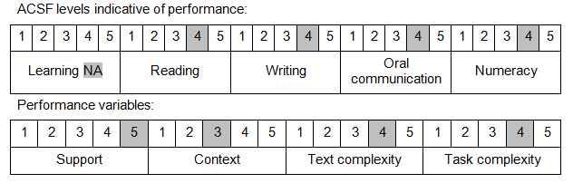

Further information on ACSF and the foundation skills underpinning this unit can be found in the Foundation Skills Guide on the GSA website.

Unit Mapping Information
This unit supersedes and is equivalent to NWP511B Manage large dam safety surveillance.

Links
Companion Volume implementation guides are found in VETNet - https://vetnet.gov.au/Pages/TrainingDocs.aspx?q=26336bc0-04e5-49d9-8c31-46c49b6a0037
Companion Volume implementation guides are found in VETNet - https://vetnet.gov.au/Pages/TrainingDocs.aspx?q=26336bc0-04e5-49d9-8c31-46c49b6a0037
Companion Volume implementation guides are found in VETNet - https://vetnet.gov.au/Pages/TrainingDocs.aspx?q=26336bc0-04e5-49d9-8c31-46c49b6a0037
Companion Volume implementation guides are found in VETNet - https://vetnet.gov.au/Pages/TrainingDocs.aspx?q=26336bc0-04e5-49d9-8c31-46c49b6a0037

