NWPSOU025 Inspect and report on embankment dam safety
Release: 1

NWPSOU025 Inspect and report on embankment dam safety

Modification History
Release | Comments
1 | This unit was released in NWP Water Training Package release 1.0 and meets the Standards for Training Packages.  This unit supersedes and is equivalent to NWP328A Inspect and report on embankment dam safety.  - Unit code updated  - Content and formatting updated to comply with the new standards  - All PC transitioned from passive to active voice

Application
This unit describes the skills required to plan, implement and report on embankment on dam safety inspection. This requires the operator to conduct routine visual inspection and capture and report dam condition and faults, in dams constructed primarily from earth and rock materials. Dam safety operators should be aware of the damage potential of the dam and be able to recognise and report deficiencies or adverse trends that could lead to failure.
This unit applies to those with responsibility for the inspection of embankment dams and reporting of faults or trends.
The skills and knowledge described in this unit must be applied within the legislative, regulatory and policy environment in which they are carried out. Organisational policies and procedures must be consulted and adhered to.
Those undertaking this unit would work under supervision while performing routine tasks in range of familiar contexts.
No licensing, legislative or certification requirements apply to unit at the time of publication.

Competency Field
Source

Elements and Performance Criteria
ELEMENTS | PERFORMANCE CRITERIA
Elements describe the essential outcomes | Performance criteria describe the performance needed to demonstrate achievement of the element. Where bold italicised text is used, further information is detailed in the range of conditions section.
1. Plan and prepare embankment dam inspection | 1.1 Identify and apply organisational requirements relating to embankment dam safety inspection.  1.2 Identify features of embankment dam types and their applications to the dams to be inspected.  1.3 Identify embankment dam behaviour under a range of conditions.  1.4 Gather and validate checklists and previous inspection reports.  1.5 Schedule activities for embankment dam inspection.
2. Inspect and assess the condition of components of embankment dams | 2.1 Implement embankment dam inspection procedures and practices including for unusual events.  2.2 Inspect and assess the condition and performance of identified areas and features of embankment dams.  2.3 Recognise, record and assess any faults and changes in the condition of the embankment dam and its appurtenant structures.
3. Report the condition of the components of embankment dams | 3.1 Identify the purpose and audience of dam safety reports.  3.2 Collect and record measurements and evidence to establish the extent of changes in conditions.  3.3 Prepare and submit reports to meet organisational requirements.

Foundation Skills
The foundation skills demands of this unit have been mapped for alignment with the Australian Core Skills Framework (ACSF). The following tables outline the performance levels indicated for successful attainment of the unit.

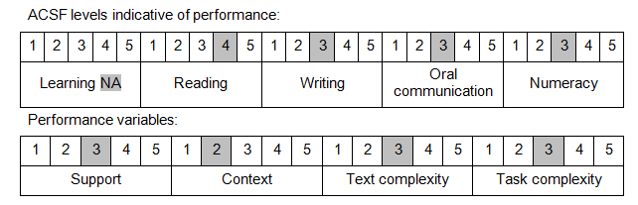

Further information on ACSF and the foundation skills underpinning this unit can be found in the Foundation Skills Guide on the GSA website.

Unit Mapping Information
This unit supersedes and is equivalent to NWP328A Inspect and report on embankment dam safety.

Links
Companion Volume implementation guides are found in VETNet - https://vetnet.education.gov.au/Pages/TrainingDocs.aspx?q=26336bc0-04e5-49d9-8c31-46c49b6a0037
Companion Volume implementation guides are found in VETNet - https://vetnet.education.gov.au/Pages/TrainingDocs.aspx?q=26336bc0-04e5-49d9-8c31-46c49b6a0037
Companion Volume implementation guides are found in VETNet - https://vetnet.education.gov.au/Pages/TrainingDocs.aspx?q=26336bc0-04e5-49d9-8c31-46c49b6a0037
Companion Volume implementation guides are found in VETNet - https://vetnet.education.gov.au/Pages/TrainingDocs.aspx?q=26336bc0-04e5-49d9-8c31-46c49b6a0037

