NWPSOU024 Inspect and report on concrete dam safety
Release: 1

NWPSOU024 Inspect and report on concrete dam safety

Modification History
Release | Comments
1 | This unit was released in NWP Water Training Package release 1.0 and meets the Standards for Training Packages.  This unit supersedes and is equivalent to NWP327A Inspect and report on concrete dam safety.  - Unit code updated  - Content and formatting updated to comply with the new standards  - All PC transitioned from passive to active voice

Application
This unit describes the skills required to plan, implement and report on concrete and masonry around dam safety inspection. This requires the operator to conduct routine visual inspections, to capture and report dam condition and faults in dams. Dam safety operators should be aware of the damage potential of the dam and be able to recognise and report deficiencies, or adverse trends that could lead to failure.
This unit applies to those working as operators with responsibility for the inspection of concrete dams and reporting of faults or trends.
The skills and knowledge described in this unit must be applied within the legislative, regulatory and policy environment in which they are carried out. Organisational policies and procedures must be consulted and adhered to.
Those undertaking this unit would work under indirect supervision while performing routine tasks in a limited range of familiar contexts.
No licensing, legislative or certification requirements apply to unit at the time of publication.

Competency Field
Source

Elements and Performance Criteria
ELEMENTS | PERFORMANCE CRITERIA
Elements describe the essential outcomes | Performance criteria describe the performance needed to demonstrate achievement of the element. Where bold italicised text is used, further information is detailed in the range of conditions section.
1. Plan and prepare concrete dam inspection | 1.1 Identify and apply the relevant organisational procedures and proformas relating to concrete dam safety inspection.  1.2 Identify features and applications of concrete dam types to be inspected.  1.3 Identify concrete dam behaviour under a range of conditions.  1.4 Assess information from checklists and previous inspection reports.  1.5 Schedule activities and equipment for concrete dam inspection according to workplace requirements.
2. Inspect and assess the condition of components of concrete dams | 2.1 Implement concrete dam inspection procedures and practices including for unusual events.  2.2 Inspect and assess the condition and performance of identified areas and features of the concrete dam.  2.3 Recognise, record and assess any faults and changes in the condition of the concrete dam and its structures.
3. Report the condition of the components of the concrete dams | 3.1 Compare observations with previous inspection reports.  3.2 Collect and record evidence to establish the extent of changes in conditions.  3.3 Prepare and submit inspection reports.  3.4 Report significant changes and deviations with recommendations for follow up action.

Foundation Skills
The foundation skills demands of this unit have been mapped for alignment with the Australian Core Skills Framework (ACSF). The following tables outline the performance levels indicated for successful attainment of the unit.

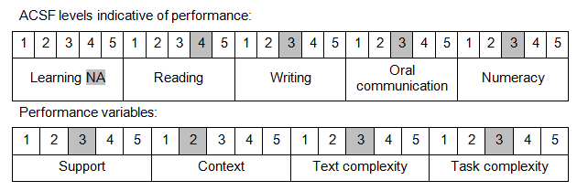

Further information on ACSF and the foundation skills underpinning this unit can be found in the Foundation Skills Guide on the GSA website.

Unit Mapping Information
This unit supersedes and is equivalent to NWP327A Inspect and report on concrete dam safety.

Links
Companion Volume implementation guides are found in VETNet - https://vetnet.education.gov.au/Pages/TrainingDocs.aspx?q=26336bc0-04e5-49d9-8c31-46c49b6a0037
Companion Volume implementation guides are found in VETNet - https://vetnet.education.gov.au/Pages/TrainingDocs.aspx?q=26336bc0-04e5-49d9-8c31-46c49b6a0037
Companion Volume implementation guides are found in VETNet - https://vetnet.education.gov.au/Pages/TrainingDocs.aspx?q=26336bc0-04e5-49d9-8c31-46c49b6a0037
Companion Volume implementation guides are found in VETNet - https://vetnet.education.gov.au/Pages/TrainingDocs.aspx?q=26336bc0-04e5-49d9-8c31-46c49b6a0037

