NWPSOU023 Monitor and implement dam maintenance
Release: 1

NWPSOU023 Monitor and implement dam maintenance

Modification History
Release | Comments
1 | This unit was released in NWP Water Training Package release 1.0 and meets the Standards for Training Packages.  This unit supersedes and is equivalent to NWP320B Monitor and implement dam maintenance.  - Unit code updated  - Content and formatting updated to comply with the new standards  - All PC transitioned from passive to active voice  - PC 1.1, 1.2 and 2.1 removed  - Two new PC added to Elements 1 and 2

Application
This unit describes the skills required to implement dam maintenance programs, including maintenance of dam safety mechanisms. The ability to interpret technical documentation, investigate and resolve maintenance problems and to collect and analyse technical information is essential to performance.
This unit applies to those working as field and operational staff with a specific responsibility for the maintenance of ungated dams.
The skills and knowledge described in this unit must be applied within the legislative, regulatory and policy environment in which they are carried out. Organisational policies and procedures must be consulted and adhered to manufacturer’s specifications.
Those undertaking this unit would work under supervision while performing routine tasks in a limited range of familiar contexts.
No licensing, legislative or certification requirements apply to unit at the time of publication.

Competency Field
Source

Elements and Performance Criteria
ELEMENTS | PERFORMANCE CRITERIA
Elements describe the essential outcomes | Performance criteria describe the performance needed to demonstrate achievement of the element. Where bold italicised text is used, further information is detailed in the range of conditions section.
1. Plan and prepare for dam maintenance | 1.1 Plan and prepare for dam maintenance according to management plans and relevant documentation.  1.2 Undertake inspection procedures.  1.3 Develop a maintenance plan.
2. Implement dam maintenance plans | 2.1 Schedule dam maintenance works.  2.2 Maintain and repair civil and mechanical dam assets.  2.3 Operate and test equipment including winches, valves and gates.
3. Compile maintenance and inspection reports | 3.1 Collect required data from inspections, measurement instruments and delegated personnel.  3.2 Collate, process, evaluate, validate, record and store data.  3.3 Record and report structural, material and/or equipment problems.  3.4 Recommend remedial action.

Foundation Skills
The foundation skills demands of this unit have been mapped for alignment with the Australian Core Skills Framework (ACSF). The following tables outline the performance levels indicated for successful attainment of the unit.

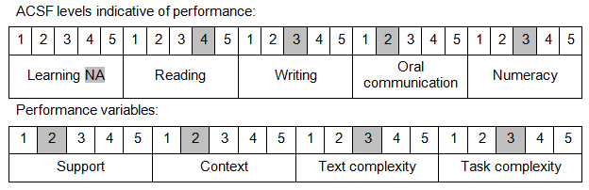

Further information on ACSF and the foundation skills underpinning this unit can be found in the Foundation Skills Guide on the GSA website.

Range of Conditions
Dam types include: | - concrete  - embankment

Unit Mapping Information
This unit supersedes and is equivalent to NWP320B Monitor and implement dam maintenance.

Links
Companion Volume implementation guides are found in VETNet - https://vetnet.gov.au/Pages/TrainingDocs.aspx?q=26336bc0-04e5-49d9-8c31-46c49b6a0037
Companion Volume implementation guides are found in VETNet - https://vetnet.gov.au/Pages/TrainingDocs.aspx?q=26336bc0-04e5-49d9-8c31-46c49b6a0037
Companion Volume implementation guides are found in VETNet - https://vetnet.gov.au/Pages/TrainingDocs.aspx?q=26336bc0-04e5-49d9-8c31-46c49b6a0037
Companion Volume implementation guides are found in VETNet - https://vetnet.gov.au/Pages/TrainingDocs.aspx?q=26336bc0-04e5-49d9-8c31-46c49b6a0037

