NWPSOU022 Monitor and control dam operations
Release: 1

NWPSOU022 Monitor and control dam operations

Modification History
Release | Comments
1 | This unit was released in NWP Water Training Package release 1.0 and meets the Standards for Training Packages.  This unit supersedes and is equivalent to NWP319A Monitor and control dam operations.  - Unit code updated  - Content and formatting updated to comply with the new standards  - All PC transitioned from passive to active voice  - PC 1.2 and 1.3 removed  - One new PC added to Element 1

Application
This unit describes the skills required to prepare for and implement dam operation plans, including inspection and testing of dam safety mechanisms.
This unit applies to those working as field and operational staff with a specific responsibility for the operation of ungated dams.
The skills and knowledge described in this unit must be applied within the legislative, regulatory and policy environment in which they are carried out. Organisational policies and procedures must be consulted and adhered to.
Those undertaking this unit would work under supervision while performing routine tasks in a limited range of familiar contexts.
No licensing, legislative or certification requirements apply to unit at the time of publication.

Competency Field
Source

Elements and Performance Criteria
ELEMENTS | PERFORMANCE CRITERIA
Elements describe the essential outcomes | Performance criteria describe the performance needed to demonstrate achievement of the element. Where bold italicised text is used, further information is detailed in the range of conditions section.
1. Plan and prepare for dam operation | 1.1 Check and apply guidelines and regulatory requirements for dam operation to operation plans.  1.2 Prepare for dam operations.
2. Implement dam operation plans | 2.1 Follow dam operation plans.  2.2 Inspect and test plant and equipment.  2.3 Test and record dam safety mechanisms.
3. Compile and process operation reports | 3.1 Collect operational data from measurement instruments, inspections and team members.  3.2 Process, evaluate, validate, record and store operational data.  3.3 Record and report structural, material and/or equipment problems.  3.4 Recommend remedial action.

Foundation Skills
The foundation skills demands of this unit have been mapped for alignment with the Australian Core Skills Framework (ACSF). The following tables outline the performance levels indicated for successful attainment of the unit.

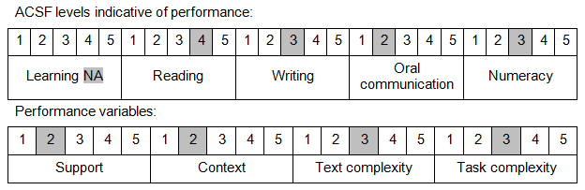

Further information on ACSF and the foundation skills underpinning this unit can be found in the Foundation Skills Guide on the GSA website.

Unit Mapping Information
This unit supersedes and is equivalent to NWP319A Monitor and control dam operations.

Links
Companion Volume implementation guides are found in VETNet - https://vetnet.gov.au/Pages/TrainingDocs.aspx?q=26336bc0-04e5-49d9-8c31-46c49b6a0037
Companion Volume implementation guides are found in VETNet - https://vetnet.gov.au/Pages/TrainingDocs.aspx?q=26336bc0-04e5-49d9-8c31-46c49b6a0037
Companion Volume implementation guides are found in VETNet - https://vetnet.gov.au/Pages/TrainingDocs.aspx?q=26336bc0-04e5-49d9-8c31-46c49b6a0037
Companion Volume implementation guides are found in VETNet - https://vetnet.gov.au/Pages/TrainingDocs.aspx?q=26336bc0-04e5-49d9-8c31-46c49b6a0037

