NWPSOU014 Develop and implement catchment operational plans
Release: 1

NWPSOU014 Develop and implement catchment operational plans

Modification History
Release | Comments
1 | This unit was released in NWP Water Training Package release 1.0 and meets the Standards for Training Packages.  This unit supersedes and is equivalent to NWP416B Coordinate and monitor water storage catchment activities.  - Unit code updated  - Content and formatting updated to comply with the new standards  - All PC transitioned from passive to active voice  - Unit title changed to better reflect unit outcomes  - PC 1.1, 1.2 and 1.4 merged  - PC 2.2 renumbered and PC 2.4 removed  - One new PC added to Element 2

Application
This unit describes the skills required to develop and implement catchment operational plans.
This unit applies to workers with a specific responsibility for ensuring that storage catchment activities comply with organisational and statutory requirements.
The skills and knowledge described in this unit must be applied within the legislative, regulatory and policy environment in which they are carried out. Organisational policies and procedures must be consulted and adhered to, particularly those related to WHS.
Those undertaking this unit would work independently or in a team, however, the level of responsibility may vary according to the size, scope, location, and technical complexity of individual projects. They would perform complex tasks, ensuring minimum damage to the environment in a familiar context.
No licensing, legislative or certification requirements apply to unit at the time of publication.

Competency Field
Source

Elements and Performance Criteria
ELEMENTS | PERFORMANCE CRITERIA
Elements describe the essential outcomes | Performance criteria describe the performance needed to demonstrate achievement of the element. Where bold italicised text is used, further information is detailed in the range of conditions section.
1. Confirm the performance measures | 1.1 Identify catchment management, stakeholder and water quality and quantity requirements.  1.2 Gather historical catchment information and apply as required.  1.3 Identify environmental factors and issues that impact on the catchment area.
2. Monitor catchment activities | 2.1 Conduct monitoring and testing programs.  2.2 Develop catchment operation and maintenance plan.  2.3 Monitor catchment area usage and maintenance activities.
3. Report outcome of testing and monitoring | 3.1 Analyse, record and report coordination and monitoring data.  3.2 Identify and investigate current and/or potential problems and report results.  3.3 Identify, investigate and report breaches of usage provisions.

Foundation Skills
The foundation skills demands of this unit have been mapped for alignment with the Australian Core Skills Framework (ACSF). The following tables outline the performance levels indicated for successful attainment of the unit.

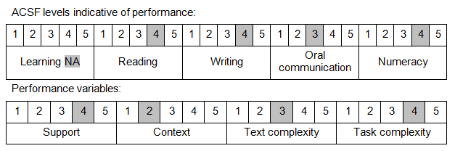

Further information on ACSF and the foundation skills underpinning this unit can be found in the Foundation Skills Guide on the GSA website.

Unit Mapping Information
This unit supersedes and is equivalent to NWP416B Coordinate and monitor water storage catchment activities.

Links
Companion Volume implementation guides are found in VETNet - https://vetnet.gov.au/Pages/TrainingDocs.aspx?q=26336bc0-04e5-49d9-8c31-46c49b6a0037
Companion Volume implementation guides are found in VETNet - https://vetnet.gov.au/Pages/TrainingDocs.aspx?q=26336bc0-04e5-49d9-8c31-46c49b6a0037
Companion Volume implementation guides are found in VETNet - https://vetnet.gov.au/Pages/TrainingDocs.aspx?q=26336bc0-04e5-49d9-8c31-46c49b6a0037
Companion Volume implementation guides are found in VETNet - https://vetnet.gov.au/Pages/TrainingDocs.aspx?q=26336bc0-04e5-49d9-8c31-46c49b6a0037

