NWPSOU011 Maintain catchment and surrounding areas
Release: 1

NWPSOU011 Maintain catchment and surrounding areas

Modification History
Release | Comments
1 | This unit was released in NWP Water Training Package release 1.0 and meets the Standards for Training Packages.  This unit supersedes and is equivalent to NWP247A Maintain catchment and surrounding areas.  - Unit code updated  - Content and formatting updated to comply with the new standards  - All PC transitioned from passive to active voice  - PC 3.2 reworded

Application
This unit of competency describes the skills required to maintain surface catchment areas and associated rivers, lakes, water bodies, dams, water storages and groundwater areas in a manner that meets organisational standards and contributes to the maintenance of water quality, and the protection of the environment and the public. The ability to maintain environmental conditions, undertake maintenance and report outcomes is essential to performance.
This unit applies to those working as field staff with specific responsibility for maintaining catchment and surrounding areas and contributing to catchment management and control.
The skills and knowledge described in this unit must be applied within the legislative, regulatory and policy environment in which they are carried out. Organisational policies and procedures must be consulted and adhered to, particularly those related to WHS, catchment security and catchment emergency response.
Those undertaking this unit would work independently or in a team, while performing routine tasks in range of familiar contexts.
No licensing, legislative or certification requirements apply to unit at the time of publication.

Competency Field
Source

Elements and Performance Criteria
ELEMENTS | PERFORMANCE CRITERIA
Elements describe the essential outcomes | Performance criteria describe the performance needed to demonstrate achievement of the element. Where bold italicised text is used, further information is detailed in the range of conditions section.
1. Prepare for work | 1.1 Access and review catchment inspection records describing maintenance requirements for action.  1.2 Identify and apply work requirements and timelines for performing maintenance tasks of catchments and surrounding areas.  1.3 Assess site, equipment and methods to be used for risks and apply appropriate control measures.  1.4 Plan maintenance work to be conducted within required timeframe, using allocated resources.
2. Maintain environmental condition of waterways and surrounding areas | 2.1 Remove and dispose of dead livestock or native fauna from waterways and surrounding catchments.  2.2 Remove flood debris from waterways and surrounding areas.  2.3 Carry out fuel reduction burns.  2.4 Apply basic control measures to contain or control chemical spills or contaminated water supplies.  2.5 Identify and report potential or emerging changes to environmental conditions.
3. Eradicate noxious weeds and feral pests | 3.1 Identify noxious weeds and feral pests that are contributing to degradation of catchment and surrounding areas.  3.2 Remove noxious weeds and feral pests.  3.3 Compile reports on eradication process.
4. Perform minor maintenance | 4.1 Identify infrastructure requiring minor maintenance.  4.2 Apply erosion control measures for waterways and surrounding areas.  4.3 Make repairs using appropriate equipment and resources to a standard that meets organisational requirements.  4.4 Record and report maintenance performed.

Foundation Skills
The foundation skills demands of this unit have been mapped for alignment with the Australian Core Skills Framework (ACSF). The following tables outline the performance levels indicated for successful attainment of the unit.

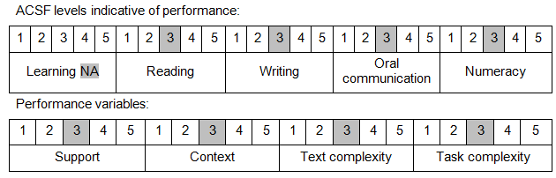

Further information on ACSF and the foundation skills underpinning this unit can be found in the Foundation Skills Guide on the GSA website.

Unit Mapping Information
This unit supersedes and is equivalent to NWP247A Maintain catchment and surrounding areas.

Links
Companion Volume implementation guides are found in VETNet - https://vetnet.gov.au/Pages/TrainingDocs.aspx?q=26336bc0-04e5-49d9-8c31-46c49b6a0037
Companion Volume implementation guides are found in VETNet - https://vetnet.gov.au/Pages/TrainingDocs.aspx?q=26336bc0-04e5-49d9-8c31-46c49b6a0037
Companion Volume implementation guides are found in VETNet - https://vetnet.gov.au/Pages/TrainingDocs.aspx?q=26336bc0-04e5-49d9-8c31-46c49b6a0037
Companion Volume implementation guides are found in VETNet - https://vetnet.gov.au/Pages/TrainingDocs.aspx?q=26336bc0-04e5-49d9-8c31-46c49b6a0037

