NWPSOU003 Identify and confirm blue-green algae outbreaks
Release: 1

NWPSOU003 Identify and confirm blue-green algae outbreaks

Modification History
Release | Comments
1 | This unit was released in NWP Water Training Package release 1.0 and meets the Standards for Training Packages.  This unit supersedes and is equivalent to NWP365A Identify and confirm blue green algae outbreaks.  - Unit code updated  - Content and formatting updated to comply with the new standards  - All PC transitioned from passive to active voice  - Element 2 removed.  - Two new Elements added

Application
This unit describes the skills required to sample, identify and confirm outbreaks of blue-green algae blooms.
This unit applies to those working as operational staff with a specific responsibility for ensuring that water and/or wastewater quality conforms to organisational standards and complies with statutory requirements.
The skills and knowledge described in this unit must be applied within the legislative, regulatory and policy environment in which they are carried out. Organisational policies and procedures must be consulted and adhered to.
Those undertaking this unit would work under supervision, while performing routine tasks within a familiar context.
No licensing, legislative or certification requirements apply to unit at the time of publication.

Competency Field
Source

Elements and Performance Criteria
ELEMENTS | PERFORMANCE CRITERIA
Elements describe the essential outcomes | Performance criteria describe the performance needed to demonstrate achievement of the element. Where bold italicised text is used, further information is detailed in the range of conditions section.
1. Confirm and conduct algae sampling | 1.1 Confirm type of samples required, procedures for sampling and sampling locations from the work instruction.  1.2 Select and prepare sampling equipment according to specified samples required.  1.3 Carry out algae sampling.  1.4 Maintain integrity of samples during sampling and label sample containers.
2. Prepare samples for testing | 2.1 Receive, handle and prepare samples for testing.  2.2 Prepare and check testing equipment for blue-green algae identification and enumeration.
3. Identify and enumerate blue-green algae | 3.1 Conduct microscopic examination of algae sample.  3.2 Determine number of cells using Sedgwick-Rafter Counting Chamber and calculate cell concentration.
4. Complete documentation | 4.1 Complete data report of the blue-green algae test results.  4.2 Report observations outside defined parameters for further action.

Foundation Skills
The foundation skills demands of this unit have been mapped for alignment with the Australian Core Skills Framework (ACSF). The following tables outline the performance levels indicated for successful attainment of the unit.

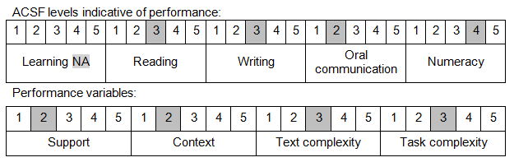

Further information on ACSF and the foundation skills underpinning this unit can be found in the Foundation Skills Guide on the GSA website.

Range of Conditions
Types of sample techniques include: | - grab  - integrated  - concentrated

Unit Mapping Information
This unit supersedes and is equivalent to NWP365A Identify and confirm blue green algae outbreaks.

Links
Companion Volume implementation guides are found in VETNet - https://vetnet.education.gov.au/Pages/TrainingDocs.aspx?q=26336bc0-04e5-49d9-8c31-46c49b6a0037
Companion Volume implementation guides are found in VETNet - https://vetnet.education.gov.au/Pages/TrainingDocs.aspx?q=26336bc0-04e5-49d9-8c31-46c49b6a0037
Companion Volume implementation guides are found in VETNet - https://vetnet.education.gov.au/Pages/TrainingDocs.aspx?q=26336bc0-04e5-49d9-8c31-46c49b6a0037
Companion Volume implementation guides are found in VETNet - https://vetnet.education.gov.au/Pages/TrainingDocs.aspx?q=26336bc0-04e5-49d9-8c31-46c49b6a0037

