NWPSOU002 Control vegetation on a site
Release: 1

NWPSOU002 Control vegetation on a site

Modification History
Release | Comments
1 | This unit was released in NWP Water Training Package release 1.0 and meets the Standards for Training Packages.  This unit supersedes and is equivalent to NWP227B Control vegetation on a site.  - Unit code updated  - Content and formatting updated to comply with the new standards  - All PC transitioned from passive to active voice

Application
This unit describes the skills required to control vegetation on a site by inspecting, identifying and treating weeds, plants and shrubs. The ability to plan and undertake work safely, including the safe handling of chemicals and equipment, is essential to performance.
This unit applies to those working as field and operational staff involved in plant control, but it does not reflect the requirements for undertaking plant control on the properties of third parties where further training and licensing requirements may apply.
The skills and knowledge described in this unit must be applied within the legislative, regulatory and policy environment in which they are carried out. Organisational policies and procedures must be consulted and adhered to.
Those undertaking this unit would work under supervision, while performing routine tasks, in familiar context.
No licensing, legislative or certification requirements apply to unit at the time of publication.

Competency Field
Source

Elements and Performance Criteria
ELEMENTS | PERFORMANCE CRITERIA
Elements describe the essential outcomes | Performance criteria describe the performance needed to demonstrate achievement of the element. Where bold italicised text is used, further information is detailed in the range of conditions section.
1. Plan and prepare work | 1.1 Organise tasks according to job specifications, relevant legislation and organisational procedures.  1.2 Perform site check to prevent damage to other utilities and environment.  1.3 Select and check equipment, personal protective equipment and material safety data sheets to meet safety requirements of task and site.  1.4 Identify noxious weeds, plants and shrubs.
2. Treat vegetation | 2.1 Conduct monitoring programs to determine spread, growth rate and extent of problem caused by weeds.  2.2 Store, handle, transport and mix chemicals and other control mechanisms.  2.3 Use processes to treat vegetation.  2.4 Implement controls to minimise environmental damage and deal with emergencies and spillage.
3. Check work and restore work site | 3.1 Clean equipment after use and prepare for safe storage or re-use.  3.2 Identify potential hazards and dispose of waste.
4. Complete records and reports | 4.1 Record use of chemicals and control mechanisms.  4.2 Complete work reports and documentation.

Foundation Skills
The foundation skills demands of this unit have been mapped for alignment with the Australian Core Skills Framework (ACSF). The following tables outline the performance levels indicated for successful attainment of the unit.

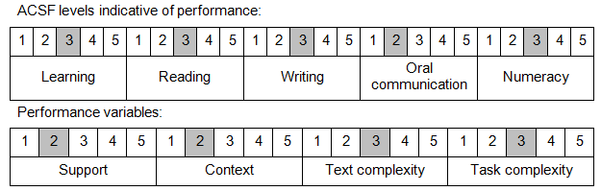

Further information on ACSF and the foundation skills underpinning this unit can be found in the Foundation Skills Guide on the GSA website.

Unit Mapping Information
This unit supersedes and is equivalent to NWP227B Control vegetation on a site.

Links
Companion Volume implementation guides are found in VETNet - https://vetnet.gov.au/Pages/TrainingDocs.aspx?q=26336bc0-04e5-49d9-8c31-46c49b6a0037
Companion Volume implementation guides are found in VETNet - https://vetnet.gov.au/Pages/TrainingDocs.aspx?q=26336bc0-04e5-49d9-8c31-46c49b6a0037
Companion Volume implementation guides are found in VETNet - https://vetnet.gov.au/Pages/TrainingDocs.aspx?q=26336bc0-04e5-49d9-8c31-46c49b6a0037
Companion Volume implementation guides are found in VETNet - https://vetnet.gov.au/Pages/TrainingDocs.aspx?q=26336bc0-04e5-49d9-8c31-46c49b6a0037

