NWPNET045 Test and commission wastewater collection systems
Release: 1

NWPNET045 Test and commission wastewater collection systems

Modification History
Release | Comments
1 | This unit was released in NWP Water Training Package release 1.0 and meets the Standards for Training Packages.  This unit supersedes and is equivalent to NWP308B Test and commission wastewater collection systems.  - Unit code updated  - Content and formatting updated to comply with the new standards  - All PC transitioned from passive to active voice  - One new PC added to Element 4  - PC 4.1 and 4.2 merged

Application
This unit describes the outcomes required to plan and implement the testing and commissioning of wastewater collection systems. The ability to interpret technical information, identify and assess hazards and perform technical testing procedures is essential to performance.
This unit applies to those working as field staff and operators with specific responsibility for commissioning wastewater collection systems, post-installation or repair, and for ensuring that the functioning of the system complies with relevant specifications and organisational requirements.
The skills and knowledge described in this unit must be applied within the legislative, regulatory and policy environment in which they are carried out. Organisational policies and procedures must be consulted and adhered to, particularly those related to WHS, and manufacturer specifications.
Those undertaking this unit would work under indirect supervision, while performing routine tasks in a familiar context, ensuring minimum damage to the environment.
No licensing, legislative or certification requirements apply to unit at the time of publication.

Competency Field
Networks

Elements and Performance Criteria
ELEMENTS | PERFORMANCE CRITERIA
Elements describe the essential outcomes | Performance criteria describe the performance needed to demonstrate achievement of the element. Where bold italicised text is used, further information is detailed in the range of conditions section.
1. Plan and prepare for testing and commissioning | 1.1 Identify and interpret the system operation requirements.  1.2 Confirm and schedule testing and commissioning tasks.  1.3 Identify and assess potential hazards and take required preventative measures.  1.4 Select and use tools and equipment.  1.5 Check testing equipment for accuracy and correct malfunctions.
2. Conduct pipeline and access structure testing procedures | 2.1 Select and install tensioning and measuring equipment.  2.2 Select and fit gauges of the correct range to test equipment.  2.3 Carry out testing procedures.  2.4 Locate failed pipes, joints and fittings and reschedule reporting and testing.  2.5 Locate and report failed maintenance holes, inspection shafts, maintenance shafts or other access structures and reschedule further testing.
3. Commission the wastewater collection system. | 3.1 Ensure the system is operational.  3.2 Restore the work site.  3.3 Check, maintain and store equipment tools and materials.
4. Record and report results | 4.1 Maintain workplace and calibration records and certificates.  4.2 Collect and store all testing and compliance results.

Foundation Skills
The foundation skills demands of this unit have been mapped for alignment with the Australian Core Skills Framework (ACSF). The following tables outline the performance levels indicated for successful attainment of the unit.

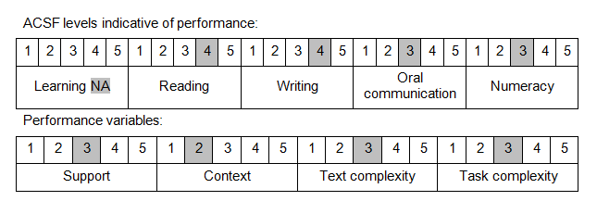

Further information on ACSF and the foundation skills underpinning this unit can be found in the Foundation Skills Guide on the GSA website.

Unit Mapping Information
This unit supersedes and is equivalent to NWP308B Test and commission wastewater collection systems.

Links
Companion Volume implementation guides are found in VETNet - https://vetnet.education.gov.au/Pages/TrainingDocs.aspx?q=26336bc0-04e5-49d9-8c31-46c49b6a0037
Companion Volume implementation guides are found in VETNet - https://vetnet.education.gov.au/Pages/TrainingDocs.aspx?q=26336bc0-04e5-49d9-8c31-46c49b6a0037
Companion Volume implementation guides are found in VETNet - https://vetnet.education.gov.au/Pages/TrainingDocs.aspx?q=26336bc0-04e5-49d9-8c31-46c49b6a0037
Companion Volume implementation guides are found in VETNet - https://vetnet.education.gov.au/Pages/TrainingDocs.aspx?q=26336bc0-04e5-49d9-8c31-46c49b6a0037

