NWPNET043 Monitor and operate bulkwater transfer systems
Release: 1

NWPNET043 Monitor and operate bulkwater transfer systems

Modification History
Release | Comments
1 | This unit was released in NWP Water Training Package release 1.0 and meets the Standards for Training Packages.  This unit supersedes and is equivalent to NWP258B Monitor and operate bulkwater transfer systems.  - Unit code updated  - Content and formatting updated to comply with the new standards  - All PC transitioned from passive to active voice  - Element 4 removed  - PC 1.4 and 3.3 removed  - PC 1.3 revised

Application
This unit describes the skills required to monitor and operate bulkwater transfer systems.
This unit applies to those working as staff with specific responsibility for ensuring that the operation of bulk water transfer systems complies with legislative and organisational requirements.
The skills and knowledge described in this unit must be applied within the legislative, regulatory and policy environment in which they are carried out. Organisational policies and procedures must be consulted and adhered to, particularly those related to WHS.
Those undertaking this unit would work under indirect supervision, while performing routine tasks in a familiar context, ensuring minimum damage to the environment.
No licensing, legislative or certification requirements apply to unit at the time of publication.

Competency Field
Networks

Elements and Performance Criteria
ELEMENTS | PERFORMANCE CRITERIA
Elements describe the essential outcomes | Performance criteria describe the performance needed to demonstrate achievement of the element. Where bold italicised text is used, further information is detailed in the range of conditions section.
1. Plan and prepare work | 1.1 Determine work requirements for operation and monitoring of bulkwater transfer systems are in line with specifications and instructions.  1.2 Perform site check to prevent damage to other utilities and the environment.  1.3 Select and check equipment to meet safety requirements of task and site.  1.4 Select, fit and use personal protective equipment.
2. Monitor system performance and usage | 2.1 Conduct routine monitoring programs according to organisational maintenance schedules.  2.2 Identify fluctuations in demand and system changes causing dirty water.  2.3 Collect, analyse and record data on system performance and usage.  2.4 Collect and record water samples.
3. Regulate flow | 3.1 Monitor and adjust flow regulating systems to meet demand requirements.  3.2 Regulate and divert flows to facilitate repair or emergency activities.

Foundation Skills
The foundation skills demands of this unit have been mapped for alignment with the Australian Core Skills Framework (ACSF). The following tables outline the performance levels indicated for successful attainment of the unit.

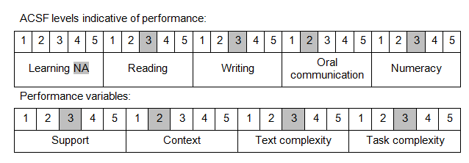

Further information on ACSF and the foundation skills underpinning this unit can be found in the Foundation Skills Guide on the GSA website

Unit Mapping Information
This unit supersedes and is equivalent to NWP258B Monitor and operate bulkwater transfer systems.

Links
Companion Volume implementation guides are found in VETNet - https://vetnet.education.gov.au/Pages/TrainingDocs.aspx?q=26336bc0-04e5-49d9-8c31-46c49b6a0037
Companion Volume implementation guides are found in VETNet - https://vetnet.education.gov.au/Pages/TrainingDocs.aspx?q=26336bc0-04e5-49d9-8c31-46c49b6a0037
Companion Volume implementation guides are found in VETNet - https://vetnet.education.gov.au/Pages/TrainingDocs.aspx?q=26336bc0-04e5-49d9-8c31-46c49b6a0037
Companion Volume implementation guides are found in VETNet - https://vetnet.education.gov.au/Pages/TrainingDocs.aspx?q=26336bc0-04e5-49d9-8c31-46c49b6a0037

