NWPNET033 Coordinate and monitor water asset construction
Release: 1

NWPNET033 Coordinate and monitor water asset construction

Modification History
Release | Comments
1 | This unit was released in NWP Water Training Package release 1.0 and meets the Standards for Training Packages.  - New unit, created drawing upon information from deleted units NWP410C and NWP525B

Application
This unit describes the skills required to coordinate and monitor asset construction, including site management and associated commissioning and post-commissioning activities. This requires the ability to conduct often complex planning of activities including the scheduling and resourcing of projects and the monitoring of the project to ensure the completion of the work in line with the organisation’s requirements and to the required quality.
This unit applies to those working as operators with responsibility for ensuring that asset construction activities are performed and completed in compliance with all relevant organisational and statutory requirements.
The skills and knowledge described in this unit must be applied within the legislative, regulatory and policy environment in which they are carried out. Organisational policies and procedures must be consulted and adhered to.
Those undertaking this unit would work independently or in a team, and may be responsible for the coordination of an operational team. They would perform complex tasks in a familiar context, ensuring minimum damage to the environment. However, the level of responsibility may vary according to the size, scope, location and technical complexity of individual projects.
No licensing, legislative or certification requirements apply to unit at the time of publication.

Competency Field
Networks

Elements and Performance Criteria
ELEMENTS | PERFORMANCE CRITERIA
Elements describe the essential outcomes | Performance criteria describe the performance needed to demonstrate achievement of the element. Where bold italicised text is used, further information is detailed in the range of conditions section.
1. Plan and prepare for asset construction | 1.1 Conduct risk assessment.  1.2 Determine and record work requirements, materials and configurations according to task from plans, specifications, instructions and or organisational procedures.  1.3 Conduct site inspections.  1.4 Select and source materials to complete the job.  1.5 Sequence and schedule work to meet organisational requirements and the efficient completion of the project.  1.6 Review networks system operations.  1.7 Identify and address stakeholder issues.  1.8 Identify and check construction guidelines, standards and other regulatory requirements.  1.9 Collate and check project documentation and assess for impact on work planning.  1.10 Identify and specify roles and responsibilities of all parties.
2. Monitor construction | 2.1 Monitor material handling procedures.  2.2 Monitor tasks and jobs to ensure compliance with plans in terms of time frames, quality assurance issues and organisational requirements.  2.3 Conduct inspections by applying commissioning programs according to commissioning and stakeholders’ requirements.  2.4 Monitor test results to ensure that the assets function within agreed specifications.  2.5 Provide guidance to contractors or employees.
3. Conduct post construction activities | 3.1 Monitor asset performance and undertake a review of the construction or installation.  3.2 Identify defects and make arrangements to rectify them.  3.3 Ensure completion and recording of all reports and documentation required by the organisation.  3.4 Communicate changes to meet unforeseen requirements, resources reallocation or rescheduling and the extent of the change.  3.5 Confirm and certify completion of construction or installation.

Foundation Skills
The foundation skills demands of this unit have been mapped for alignment with the Australian Core Skills Framework (ACSF). The following tables outline the performance levels indicated for successful attainment of the unit.

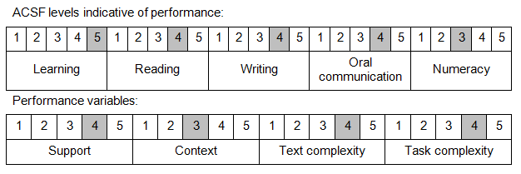

Further information on ACSF and the foundation skills underpinning this unit can be found in the Foundation Skills Guide on the GSA website.

Unit Mapping Information
No equivalent unit.

Links
Companion Volume implementation guides are found in VETNet - https://vetnet.gov.au/Pages/TrainingDocs.aspx?q=26336bc0-04e5-49d9-8c31-46c49b6a0037
Companion Volume implementation guides are found in VETNet - https://vetnet.gov.au/Pages/TrainingDocs.aspx?q=26336bc0-04e5-49d9-8c31-46c49b6a0037
Companion Volume implementation guides are found in VETNet - https://vetnet.gov.au/Pages/TrainingDocs.aspx?q=26336bc0-04e5-49d9-8c31-46c49b6a0037
Companion Volume implementation guides are found in VETNet - https://vetnet.gov.au/Pages/TrainingDocs.aspx?q=26336bc0-04e5-49d9-8c31-46c49b6a0037

