NWPNET032 Construct and install wastewater assets
Release: 1

NWPNET032 Construct and install wastewater assets

Modification History
Release | Comments
1 | This unit was released in NWP Water Training Package release 1.0 and meets the Standards for Training Packages.  This unit supersedes and is equivalent to NWP250B Construct and install wastewater pipelines.  - Unit code updated  - Content and formatting updated to comply with the new standards  - All PC transitioned from passive to active voice  - Unit title changed to better reflect unit outcomes

Application
This unit describes the skills required to construct and install wastewater collection assets.
This unit applies to those working as field staff with specific responsibility for ensuring that wastewater pipelines are constructed and installed in a safe and timely manner.
The skills and knowledge described in this unit must be applied within the legislative, regulatory and policy environment in which they are carried out. Organisational policies and procedures must be consulted and adhered to, particularly those related to manufacturer guidelines and WHS.
Those undertaking this unit would work independently or in a team using own familiar resources, while performing routine tasks in a range of familiar contexts.
No licensing, legislative or certification requirements apply to unit at the time of publication.

Competency Field
Networks

Elements and Performance Criteria
ELEMENTS | PERFORMANCE CRITERIA
Elements describe the essential outcomes | Performance criteria describe the performance needed to demonstrate achievement of the element. Where bold italicised text is used, further information is detailed in the range of conditions section.
1. Plan and prepare construction and installation of collection pipelines | 1.1 Determine work requirements for construction and installation from plans, specifications and instructions.  1.2 Perform site check to prevent damage to other utilities.  1.3 Select and check equipment and tools required to meet safety requirements of task and site.  1.4 Identify potential risks to public and environment, and take appropriate steps to minimise and eliminate risks.
2. Construct and install collection pipelines according to specifications | 2.1 Select, fit and use personal protective equipment.  2.2 Excavate and prepare trenches.  2.3 Lay bedding or foundation.  2.4 Select and lay or join pipes and fittings to grade.  2.5 Backfill excavations.
3. Review construction and installation of collection assets | 3.1 Check constructed or installed collection pipes and fittings to ensure specifications are met.  3.2 Check, maintain and store equipment, tools and materials.  3.3 Restore work site to meet environmental and organisational requirements.  3.4 Complete workplace records as constructed drawings and process.

Foundation Skills
The foundation skills demands of this unit have been mapped for alignment with the Australian Core Skills Framework (ACSF). The following tables outline the performance levels indicated for successful attainment of the unit.

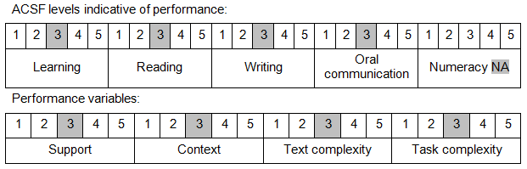

Further information on ACSF and the foundation skills underpinning this unit can be found in the Foundation Skills Guide on the GSA website.

Unit Mapping Information
This unit supersedes and is equivalent to NWP250B Construct and install wastewater pipelines.

Links
Companion Volume implementation guides are found in VETNet - https://vetnet.education.gov.au/Pages/TrainingDocs.aspx?q=26336bc0-04e5-49d9-8c31-46c49b6a0037
Companion Volume implementation guides are found in VETNet - https://vetnet.education.gov.au/Pages/TrainingDocs.aspx?q=26336bc0-04e5-49d9-8c31-46c49b6a0037
Companion Volume implementation guides are found in VETNet - https://vetnet.education.gov.au/Pages/TrainingDocs.aspx?q=26336bc0-04e5-49d9-8c31-46c49b6a0037
Companion Volume implementation guides are found in VETNet - https://vetnet.education.gov.au/Pages/TrainingDocs.aspx?q=26336bc0-04e5-49d9-8c31-46c49b6a0037

