NWPNET024 Maintain and repair network assets for bulkwater
Release: 1

NWPNET024 Maintain and repair network assets for bulkwater

Modification History
Release | Comments
1 | This unit was released in NWP Water Training Package release 1.0 and meets the Standards for Training Packages.  This unit supersedes and is equivalent to NWP244B Maintain and repair bulkwater assets.  - Unit code updated  - Content and formatting updated to comply with the new standards  - All PC transitioned from passive to active voice  - Unit title changed to better reflect unit outcomes

Application
This unit of competency describes the skills required to maintain and repair bulkwater assets, including planning and preparing for work, conducting maintenance and repair work, and cleaning, flushing and disinfecting as appropriate.
This unit applies to those working as field staff with responsibility for ensuring that maintenance and repair work on bulkwater assets is completed in a safe and timely manner.
The skills and knowledge described in this unit must be applied within the legislative, regulatory and policy environment in which they are carried out. Organisational policies and procedures must be consulted and adhered to, particularly those related to manufacturers’ guidelines, WHS, lock out, disinfection and maintenance.
Those undertaking this unit would work independently or in a team using own familiar resources, while performing routine tasks in a range of familiar contexts.
No licensing, legislative or certification requirements apply to unit at the time of publication.

Competency Field
Networks

Elements and Performance Criteria
ELEMENTS | PERFORMANCE CRITERIA
Elements describe the essential outcomes | Performance criteria describe the performance needed to demonstrate achievement of the element. Where bold italicised text is used, further information is detailed in the range of conditions section.
1. Plan and prepare for maintenance | 1.1 Determine work requirements for the maintenance and repair of assets from work drawings, plans, specifications and instructions.  1.2 Select and check equipment and tools required to meet safety requirements of task and site.  1.3 Select, fit and use personal protective equipment.
2. Maintain and repair assets, pipes and fittings | 2.1 Repair or replace leakages and damaged assets.  2.2 Check and clean pipes and fittings before use.  2.3 Select fittings and tools and lay and/or join assets.  2.4 Conduct preventative maintenance according to organisational maintenance programs.  2.5 Perform cleaning, flushing and disinfection.  2.6 Check work to ensure that specifications have been met.
3. Finalise work | 3.1 Check, maintain and store equipment, tools and materials.  3.2 Restore work site to meet environmental and organisational requirements.  3.3 Complete workplace records and process them as required.

Foundation Skills
The foundation skills demands of this unit have been mapped for alignment with the Australian Core Skills Framework (ACSF). The following tables outline the performance levels indicated for successful attainment of the unit.

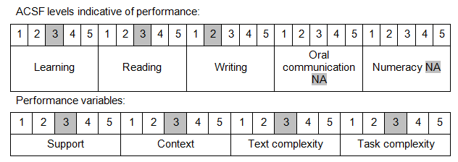

Further information on ACSF and the foundation skills underpinning this unit can be found in the Foundation Skills Guide on the GSA website.

Unit Mapping Information
This unit supersedes and is equivalent to NWP244B Maintain and repair bulkwater assets.

Links
Companion Volume implementation guides are found in VETNet - https://vetnet.education.gov.au/Pages/TrainingDocs.aspx?q=26336bc0-04e5-49d9-8c31-46c49b6a0037
Companion Volume implementation guides are found in VETNet - https://vetnet.education.gov.au/Pages/TrainingDocs.aspx?q=26336bc0-04e5-49d9-8c31-46c49b6a0037
Companion Volume implementation guides are found in VETNet - https://vetnet.education.gov.au/Pages/TrainingDocs.aspx?q=26336bc0-04e5-49d9-8c31-46c49b6a0037
Companion Volume implementation guides are found in VETNet - https://vetnet.education.gov.au/Pages/TrainingDocs.aspx?q=26336bc0-04e5-49d9-8c31-46c49b6a0037

